

**Smarter Balanced**

**Assessment Consortium:**

**Reporting System**

**User Guide**

Updated **09/07/2014**



**Contents**

1. Reporting System 5

Overview 5

1.1 Report Descriptions 6

1.1.1 Individual STUDENT Report 7

1.1.2 List of Students in a GRADE 17

1.1.3 Results by Grade for a SCHOOL 28

1.1.4 Comparing Schools in a DISTRICT 36

1.1.5 Comparing Districts in a STATE 45

1.2 Data Downloads 53

1.2.1 Student Assessment Results 54

1.2.2 Printable Student Reports 55

1.2.3 State Downloads: Overview 58

1.2.4 State Download: Student Registration Statistics 59

1.2.5 State Download: Assessment Completion Statistics 62

1.2.6 State Download: Audit XML 65

1.2.7 State Download: Individual Item Response Data 67

1.3 Reporting Features Summary 71

1.4 Inference Guidance Content Summary 77

1.5 Definition of Terms 79

1.5.1 Accessibility 79

1.5.2 Accommodations 80

1.5.3 Achievement Levels and Proficiency 80

1.5.4 Authorization 80

1.5.5 Claims Reporting 81

1.5.6 Context Security, Access Patterns, and Single Sign-On (SSO) 83

1.5.7 Error Bands and SEM 83

1.5.8 Integration with Institutes of Higher Education (IHE) 84

1.5.9 Interim Assessment Blocks (IAB) Reporting 84

1.5.10 Interim Comprehensive Assessments (ICA) Reporting 84

1.5.11 Help 86

1.5.12 HTTPS Pickup Zone 86

1.5.13 Language Support 86

1.5.14 Legends 86

1.5.15 Logging 86

1.5.16 Displaying hidden information 86

1.5.17 Navigation 86

1.5.18 Optional Student Group 88

1.5.19 Permissions 89

1.5.20 Personally Identifiable Information (PII) Protection 89

1.5.21 Printing, Individual and Batch 89

1.5.22 Reporting API 92

1.5.23 Security 92

1.5.24 Scale Score 92

1.5.25 Section 508 Compliance 92

1.5.26 Summative Assessments 96

1.5.27 Tenancy 96

1.6 Technical Requirements 97

1.6.1 Viewing reports 97

1.6.2 Data Sources 97

1.6.3 Reporting Technology Stack 97

1.7 Member-State Configuration and Extension of the Reporting System 98

1.8 Documented Assumptions and Clarifications 99

1.8.1 Truth at Test Time 99

1.8.2 Data-Driven Hierarchy 99

1.8.3 Enrollment 99

1.8.4 Instructional Use 99

1.8.5 Statistical Analysis 100

1.8.6 Longitudinal Data and Student IDs 100

1.8.7 Comparing Aggregates 100

1.8.8 Group and Permission Definitions 100

1.8.9 System Functionality Restrictions 100

1.8.10 Statistical Support 101

1.8.11 Availability of Data 101

**List of Figures**

Figure 1 - Individual STUDENT Report 8

Figure 2 - Breadcrumb Navigation 10

Figure 3 - Individual STUDENT Report Information Indicators 11

Figure 4 - Individual STUDENT Report Legend 12

Figure 5 - Individual STUDENT Report - Overall Scores 13

Figure 6 - Individual STUDENT Report Overall Score Bar 13

Figure 7 - Individual STUDENT Report Mathematics Claim Levels 14

Figure 8 - Individual STUDENT Report ELA/Literacy Claim Levels 14

Figure 9 - Individual STUDENT Report Accommodations Reporting 15

Figure 10 - List of Students in a GRADE 18

Figure 11 - Breadcrumb Navigation 20

Figure 12 - List of Students in a GRADE Assessment Selector 20

Figure 13 - Previous Year Warning 21

Figure 14 - Mathematics overall and claim scores 21

Figure 15 - List of Students in a GRADE Information Indicators 22

Figure 16 - List of Students in a GRADE Legend 23

Figure 17 - Download Options Window 24

Figure 18 - List of Students in a GRADE Sorting 25

Figure 19 - List of Students in a GRADE Filter Options 25

Figure 20 - List of Students in a GRADE Selection 26

Figure 21 - Results by Grade for a SCHOOL 28

Figure 22 - Breadcrumb Navigation 29

Figure 23 - Results by Grade for a SCHOOL Information Indicators 30

Figure 24 - Results by Grade for a SCHOOL Legend 31

Figure 25 - Download Options Window 32

Figure 26 - Results by Grade for a SCHOOL Filter Options 33

Figure 27 - Align Feature 34

Figure 28 - Student population detail popup window 34

Figure 29 - Comparing Schools in a DISTRICT 37

Figure 30 - Breadcrumb Navigation 38

Figure 31 - Previous Year Warning Message 39

Figure 32 - Comparing Schools in a DISTRICT Information Indicators 39

Figure 33 - Comparing Schools in a DISTRICT Legend 40

Figure 34 - Download Options Window 41

Figure 35 - Results by Grade for a SCHOOL Filter Options 42

Figure 36 - Align Feature 43

Figure 37 - Student population detail popup window 44

Figure 38 - Comparing Districts in a STATE 45

Figure 39 - Previous Year Warning Message 47

Figure 40 - Comparing Schools in a DISTRICT Information Indicators 47

Figure 41 - Comparing Schools in a DISTRICT Legend 48

Figure 42 - Download Options Window 49

Figure 43 - Results by Grade for a SCHOOL Filter Options 50

Figure 44 - Align Feature 51

Figure 45 - Student population detail popup window 52

Figure 46 - Download Popup Window 55

Figure 47 - Download Printable Student Report Options 55

Figure 48 - Download Confirmation Window 56

Figure 49 - Printable Student Reports Cover Page 56

Figure 50 - Printable Student Reports Segment Cover Page 57

Figure 51 - Download Popup Window 58

Figure 52 - State Download selector 58

Figure 53 - Download Confirmation Window 59

Figure 54 - Download Confirmation Window 62

Figure 55 - State Downloads Window 65

Figure 56 - Download Confirmation Window 66

Figure 57 - State Downloads Window 67

Figure 58 - Download Confirmation Window 68

Figure 59 - Accommodations Display 80

Figure 60 - Claims Score Illustration 81

Figure 61 - Error Band Illustration 83

Figure 62 - Reporting Landing Page (for logged out users) 87

Figure 63 - Breadcrumb Navigation 87

Figure 64 - Optional Student Group Filter 88

Figure 65 - Download Popup Window 90

Figure 66 - Printable Student Report options 91

Figure 67 - Download Confirmation Window 91

Figure 68 - List of Students in a GRADE, Download Current View as CSV example 93

Figure 69 - Download Current View as CSV - Suppressed Data 93

Figure 70 - Download Current View as CSV aggregate report 94

Figure 71 - Comparing Districts in a STATE: Download options 95

Figure 72 - Download Current View as CSV aggregate report 95

Figure 73 - Member State Customizable Logo and Title 98

Figure 74 - Member State Configurable Resources 99

# Reporting System

## Overview

Amplify has created an innovative and intuitive reporting and data visualization platform that brings the criterion-referenced Smarter Balanced summative and interim comprehensive assessment outcomes data to life for teachers and administrators. Reporting designs for the Interim Assessment Blocks will be added in a future version of this document. Using this system, educators can view aggregates of student result data at the state, district, school, and grade levels, and teachers with the correct levels of personally identifiable information (PII) access permissions can view Individual STUDENT Reports and share them with parents.

This section describes:

* Each report in detail
* Functional elements and the reports where they appear
* Terms and concepts that have specific definitions in the reporting context
* Technical requirements fulfilled by the reports
* How member states can further enhance the reporting platform
* Areas of ambiguity that have been clarified with the Consortium

Reporting is built upon the foundation of the individual student assessment. Each test record includes a scale score, a determination of which of four Achievement Levels that score signifies, information about the student, his or her school, and the test itself.

The reports that display individual student results communicate scores and Achievement Levels, but also explain their meaning by offering guidance on career- and college content-readiness through the “Achievement Level Descriptors” and “Report Information.” These reports also detail students’ achievement against grade-specific standards at more granular levels through the mathematics and ELA/literacy claims. Student reports can be downloaded for printing in batches, or individually, in multiple languages (English, Spanish, Vietnamese) and either in grayscale or in full color.

The aggregate reports build on the concept of overall subject Achievement Levels to display intuitive horizontal bar charts that characterize the proportion of students in each level. Each report provides search, sorting, filtering, comparison of selected aggregates, and alignment options to locate and review the aggregate data relevant to the users’ needs. For aggregate reports, users with appropriate permissions can download the data as displayed, as well as additional data extracts.

The first operational version of the reporting system is intended to provide a solid foundational reporting experience, focused on clear communication of straightforward information that is gathered through the administration of Smarter Balanced summative and interim comprehensive assessments in ELA/literacy and mathematics. To that end, it provides broadly accessible, member-state common functionality that can be customized and enhanced in the future.

## Report Descriptions

The Smarter Balanced Reporting System is an interactive, online reporting platform that provides a range of reports on the Smarter Balanced summative and interim assessments. Reports provide aggregate score data at the state, district, school, and grade level. Educators may examine data at multiple levels, depending on their level of access, and can create custom subsets filtered by gender or student demographic data (LEP, Race/Ethnicity, IEP, Gender, 504, Economic Disadvantage, or Migrant Status). Aggregate reports can be viewed onscreen or downloaded as CSV files, and Individual STUDENT Reports can be downloaded as PDF files for easy printing and distribution to parents.

Student personally identifiable information (PII) is protected through the latest encryption and security technology, and users are only permitted to view data for students they have been explicitly authorized to view. Users without PII access are not permitted to view aggregates composed of fewer than 10 students or an aggregate of any size where all students are below proficient.

This document provides a static view of the reports, with annotations, previously approved by Smarter Balanced, provided to explain the different features that will be available when the system is released. Member States can utilize the system as hosted by the Consortium, utilize the open-source code to adapt the system to their needs, or utilize a different system.

The reports and extracts have been ordered in Section 2.1, and the table below provides a logical flow of information from the individual assessment result up to aggregate reporting.

Upon successful login, users enter the system at the Comparing Districts in a STATE level and can drill their way down through the aggregation hierarchy.

|  |  |
| --- | --- |
| **ID** | **Report Name** |
| 1.1.1 | Individual STUDENT Report |
| 1.1.2 | List of Students in a GRADE |
| 1.1.3 | Results by Grade for a SCHOOL |
| 1.1.4 | Comparing Schools in a DISTRICT |
| 1.1.5 | Comparing Districts in a STATE |

Table - List of Reports

### Individual STUDENT Report

This report presents individual student assessment scores and illustrates performance against grade-specific standards for a given summative or interim comprehensive assessment. The scores and descriptions provide context for understanding what the assessment has measured and how to interpret the scores and scoring categories.

Educators, students, parents and guardians may use this report to understand a student’s achievement, progress toward mastery of the Common Core State Standards and attainment of the academic knowledge and skills required to be college content- and career-ready. The report may provide context for a parent-teacher conference or, together with other instructional data, may help to identify areas for instructional focus.

A separate Individual STUDENT Report will be provided for each summative and each interim comprehensive assessment that a student has taken. Data from different assessments (i.e., summative, interim comprehensive assessment) or from different years are not viewed together in one report; each report provides data for one assessment at a time.

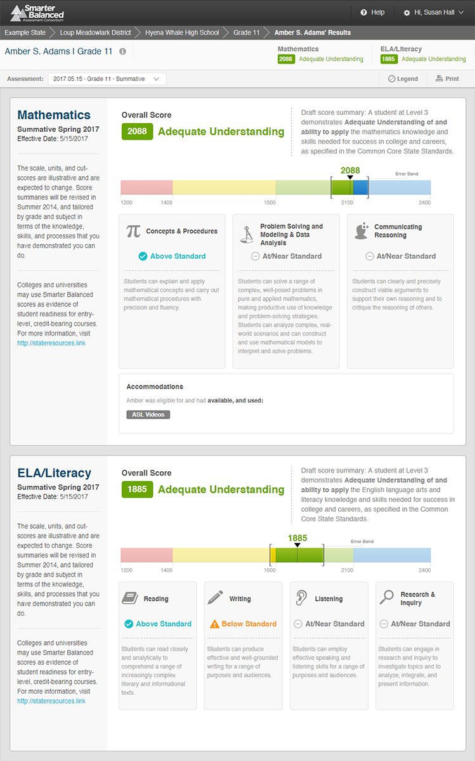

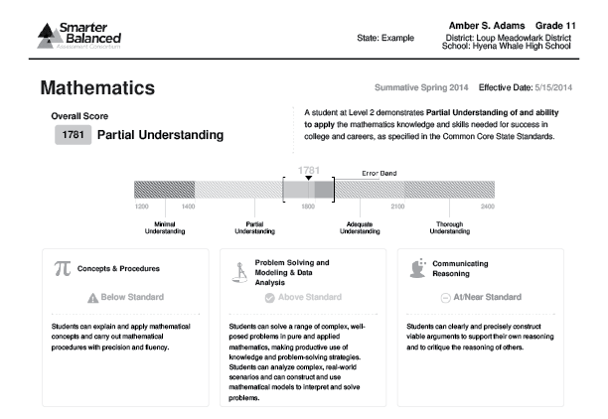

Figure - Individual STUDENT Report

#### Report Features

|  |  |
| --- | --- |
|  | **Breadcrumbs**: At the top of the page, users can navigate back to the grade, school, district, and state level reports. |
|  | **Report Information**: Detailed report information regarding the report’s purpose and its potential uses is accessible by pausing on or clicking the information icon next to the report’s title. |
|  | **Assessment Selector**: A dropdown list of all assessments that the student has taken, organized by assessment type (summative or interim) and date administered. |
|  | **Top-Level Summary**: The student’s mathematics and ELA/literacy overall scores and achievement level for the selected assessment (summative or interim). |
|  | **PDF Print**: The **Print** button presents the option of printing a PDF version of the report. Users can select various print settings, including color, grayscale (for black-and-white printing), and language. |
|  | **Achievement Level Descriptor**: The description of the student’s achievement level. |
|  | **Overall Score and Error Bands**: The overall score is indicated by a single number. This number is located visually along a continuum of scores. The score is surrounded by error bands, marked with brackets. This range indicates the range of scores that the student would be likely to achieve even if he or she took the test multiple times. |
|  | **College Content-Readiness Resources**: College and career readiness information for students in 8th and 11th grades. If available, a link to state-specific resources is provided. |
|  | **Claim Information**: Mathematics and ELA/literacy are composed of claims. Within each claim, student performance is reported as Below Standard, At/Near Standard, or Above Standard. A description of each claim is provided. |
|  | **Accommodations**: A list of accommodations available to and used by the student. |

#### Detailed Descriptions

**Navigation**

* A user with appropriate permissions may access an Individual STUDENT Report by clicking a student’s name in the List of Students in a GRADE report.
* The Individual STUDENT Report displays results for one student on one assessment at a time. A user may navigate to other individual reports for this student via the Assessment Selector.
* A user may use the breadcrumbs to navigate up to the student’s grade, school, district or state.

****

Figure - Breadcrumb Navigation

**Informational Popup Windows**

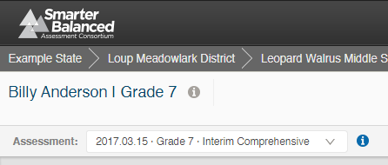

Figure - Individual STUDENT Report Information Indicators

Report Information , Interim Information , and Legend are all available by pausing on or clicking the respective icons.

The Report Information popup contains additional information about the purposes and proposed uses of the report. For the Individual Student Report, the text is as follows:

**Purpose:**

This report presents individual student assessment scores and provides guidance on how to interpret the results.

**Uses:**

Educators, parents or students may use this report to understand student achievement, progress toward mastery of the Common Core State Standards and attainment of the academic knowledge and skills required to be college content- and career-ready.

**Understanding your score:**

The Smarter Balanced assessment is different than other tests with which you may be familiar.

* First, the Smarter Balanced assessments are Computer Adaptive Tests and take advantage of technology to customize each test to the individual student. This means that when a student answers a question correctly, the next question they see will be slightly more difficult. Likewise, if an answer is incorrect, the next question will be somewhat less difficult. This procedure allows for more efficient and precise measurement of students' knowledge and skills.
* Second, the assessment is a criterion-referenced test, meaning that it reports individual students’ understanding of a particular set of academic knowledge and skills. As a result, scores are not meant to compare students to each other, but rather to determine how well each student understands the content assessed.

The Interim Information popup contains specific information about the nature of the interim assessment and suggests appropriate ways to interpret interim results. The text is as follows:

Important Information about Interim Assessments

* Questions on interim tests that require human scoring may be scored locally by teachers. This local scoring is not subject to the rigorous controls used in summative assessment and local results may show some variations.
* Interim assessment questions are not secure. Exposure to, and familiarity, with, test questions may affect student performance and the accuracy of interim results.

The legend provides a key to the visual elements of the report. It appears as follows:

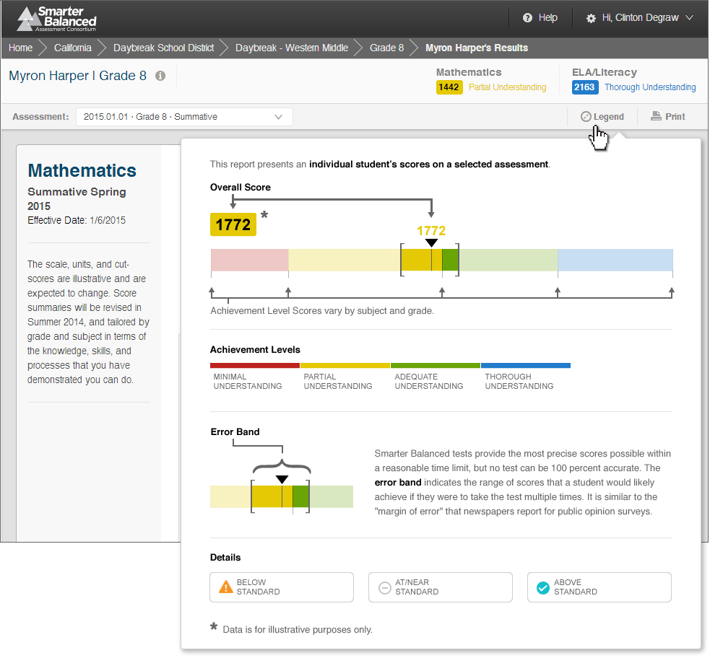

Figure - Individual STUDENT Report Legend

**Printing**

Clicking the **Print** icon allows users to print a custom-designed, printer-friendly report in PDF format in color or grayscale. The printed report contains all visible content from the report as well as all content that is presented in popup windows.

**Score Displays**

The top of the report displays mathematics and ELA/literacy overall scale scores and Achievement Levels for the assessment selected, whether summative or interim comprehensive.

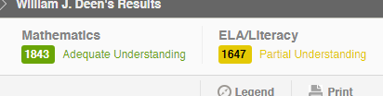

Figure - Individual STUDENT Report - Overall Scores

Under each subject header, the report displays the student’s overall score and Achievement Level on a colored band representing the range of possible scores and the achievement level scores. The Achievement Level is accompanied by an Achievement Level Descriptor (ALD) [Note: this content will be updated as part of the Achievement Level Setting process, scheduled to take place in the Fall of 2014]. The student’s score is represented by a number and a line marking a spot on the horizontal scale, surrounded by brackets indicating error bands. These error bands represent the range of scores a student might have received had they taken the test multiple times.

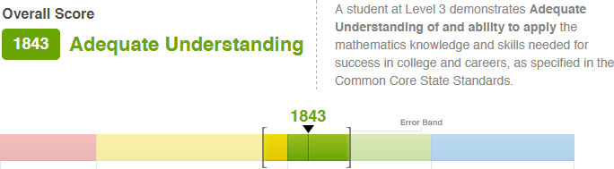

Figure - Individual STUDENT Report Overall Score Bar

Below the overall score display, the report displays the student’s Claim Level (Below Standard, At/Near Standard, Above Standard) for each of the subject’s Claims, with descriptions of what each Claim measures and what performing at a specific Level indicates about a student’s mastery of the standards.

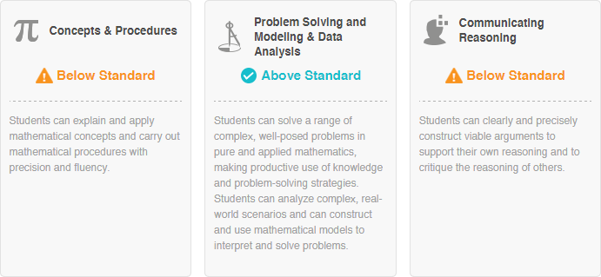

Figure - Individual STUDENT Report Mathematics Claim Levels

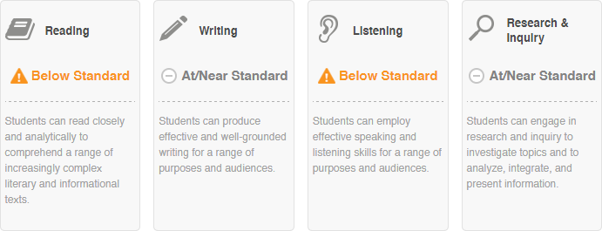

Figure - Individual STUDENT Report ELA/Literacy Claim Levels

**Reported Accommodations**

Where appropriate, the report displays “Accommodations” status messages based on the eligibility of the student (if known), availability of the accommodation (if known), and usage of accommodation (if known).

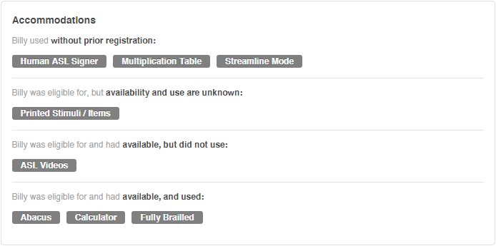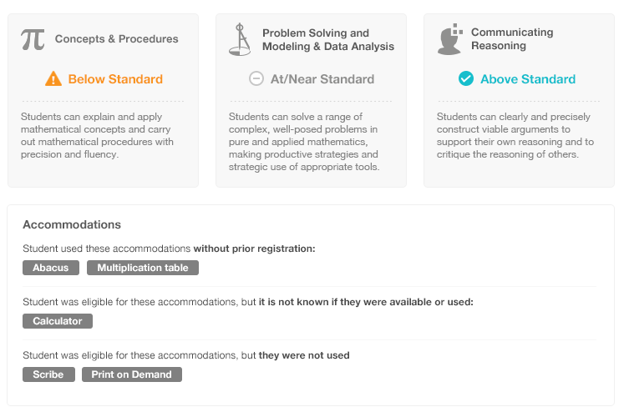

Figure - Individual STUDENT Report Accommodations Reporting

The eligibility, availability, and usage of an accommodation are subject to the capabilities of the Test Delivery System and information captured by the proctor at test time. If this information is not captured at test time, then it will not be displayed by the reporting system.

**Appropriate Uses Message**

The report displays a consortium-level message about the state of the scores reported and provides guidance to educators on how to interpret the report. The text reads as follows:

The scale, units and scores are illustrative and are expected to change. Score summaries will be revised in Summer 2014, and tailored by grade and subject in terms of the knowledge, skills, and processes that you have demonstrated you can do.

**College Content-Readiness Resources**

Reports for students’ 11th grade assessments display Consortium-common policy information, with a state-configurable link to state resources. The text reads as follows:

Colleges and universities may use Smarter Balanced scores as evidence of student readiness for entry-level, credit-bearing courses. For more information, visit [STATE-SPECIFIC LINK].

**Language Support**

The textual content of the Reporting System is available for viewing and printing in English by default, but users can select to view or print the content in either Spanish or Vietnamese.

**Student Privacy**

This report contains student personally identifiable information (PII). Therefore, only users with authorization and system permissions to access PII for this student can view this report. Authorization and permissions are set by each state and passed to the Reporting System when a user logs in to the system.

1. In order to see a given Individual STUDENT Report, a user must meet these three requirements:
   * Have appropriate external authorization to access PII
   * Be authenticated through the Smarter Balanced operational Single Sign-On component
   * Have appropriate permissions for that student assigned to their user account through the Smarter Balanced Permissions component
2. The Smarter Balanced Single Sign-On component does not contain accounts, user names or passwords for students or parents, but contains accounts with user names and passwords for registered educators and administrators. This means that parents and students cannot access the report online directly through the Consortium system, but rather mediated either by their educator/administrator or in printed form.
3. Provisioning of the Individual STUDENT Report in printer-friendly format (in either the default gray-scale or in full color) allows for offline/paper-based dissemination of the report by schools to parents.
4. The Individual STUDENT Report can be generated by an external system through an Application Programming Interface (API). States can configure systems to call the Smarter Balanced system and generate student reports on behalf of their educators. Any system that wanted to generate a student report would need the same authorizations and permissions as an individual user.
5. For parents and students to be able to see this report online via a state-operated reporting system, the state needs to integrate with the Smarter Balanced Single Sign-On component in order to authenticate their user accounts, verify their permissions, and provide their users with access.
6. The data that drive Individual STUDENT Reports—including Overall (scale score, error band, and achievement level) and Claim (scale score, error band, and claim level) data—are calculated by the Test Integration component and passed to the Data Warehouse. Neither the Reporting System nor the Data Warehouse calculate or compute scores, error bands, or performance levels.

### List of Students in a GRADE

This report provides assessment results for a list of students. The list is generated based on data available on results for summative or interim comprehensive assessments designed for the selected grade and taken during the selected Academic Year.

The list can be viewed either with mathematics and ELA/literacy side by side, or in a subject detail view that shows Overall scale scores complemented by Claim Levels (see Section 1.5.5 for more information on Claim Levels).

This list does not represent enrollment-based classes or sections, as there is no persistent teacher-student links in the Data Warehouse. However, students in the list can be filtered, sorted, and selected to assist in narrowing focus. Filters are provided using all demographic and program data available, as well as student groups that may be used as desired by member states. The list can be sorted in ascending or descending order by the values in any column (e.g., alphabetically by last name or by overall scale scores).

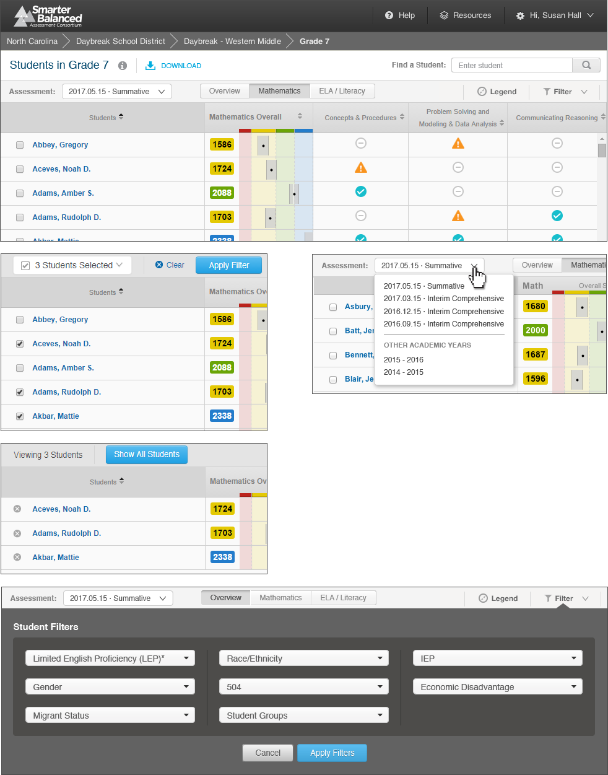

Figure - List of Students in a GRADE

|  |  |
| --- | --- |
|  | **Breadcrumbs**: At the top of the page, users can navigate back to the school, district, and state level reports. |
|  | **Report Information**: Detailed report information regarding the report’s purpose and its prospective uses is accessible by pausing on or clicking the “i” information icon next to the report’s title. |
|  | **Download**: The **Download** button allows users to download the current page as a CSV file or to download the Individual Student Reports of the listed students. |
|  | **Assessment / Academic Year Selector**: A drop-down list of all assessments that the students have taken, organized by assessment type (Summative or Interim Comprehensive) and date administered. Drop-down also allows selection of other academic years for which there is available assessment data. |
|  | **Filter**: The **Filter** button opens a window that enables advanced filtering of student results by student demographic information. |
|  | **Select a Student**: Checkboxes next to student names allow users to select specific students for comparison or printing. "Deselect all" removes the selection. |
|  | **Column Sorting**: Column headers allow users to sort the list of students by the values in each column. |
|  | **Overall Score and Error Bands**: The overall score is indicated by a single number and as a dot on a continuum of scores. The score is surrounded by error bands, marked with a gray bar. This range indicates the range of scores that the student would be likely to achieve even if he or she took the test multiple times. |
|  | **Claim Information**: Mathematics and ELA/literacy are composed of claims. Within each claim, student performance is reported as Below Standard, At/Near Standard, or Above Standard. A description of each claim is provided. |

#### Report Features

#### 

#### Detailed Descriptions

**Navigation**

* A user with appropriate permissions can access the List of Students in a GRADE report by clicking the grade in the Results by Grade for a SCHOOL report.
* A user can access the List of Students in a GRADE report by clicking the grade in the breadcrumb navigation on an Individual STUDENT Report.
* A user can use the breadcrumb navigation to go back up to the SCHOOL, DISTRICT, or STATE reports.

****

Figure - Breadcrumb Navigation

* A user must have PII access in order to see the List of Students in a GRADE report and to navigate to a student’s Individual STUDENT Reports by clicking his or her name.

**Selecting Assessment Results**

* A user can see results of any assessment with available results via the Assessment Selector. The options in the Assessment Selector are based on all results for assessments designed for that grade. If a student has no results for the selected assessment, his or her row is not displayed. If a student has results only for either mathematics or ELA/literacy, then he or she is displayed when viewing both subjects, but is not displayed for the subject where there is no result.

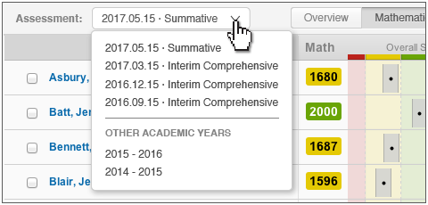

Figure - List of Students in a GRADE Assessment Selector

* A user can see report results for different years by selecting an Academic Year from the bottom of the Assessment Selector. Changing the Academic Year changes the list of students to those for whom assessment results exist for the selected grade in the selected Academic Year.

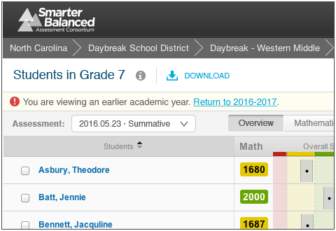

Figure - Previous Year Warning

* When a previous academic year is selected, the report displays a warning message alerting users that the students displayed are those who took the selected grade’s assessment in a prior academic year.
* By default, the report displays an Overview with results from both mathematics and ELA/literacy assessments.
* Selecting either the **Mathematics** or **ELA/Literacy** button displays a view that shows overall results and Claim levels for the selected assessment.

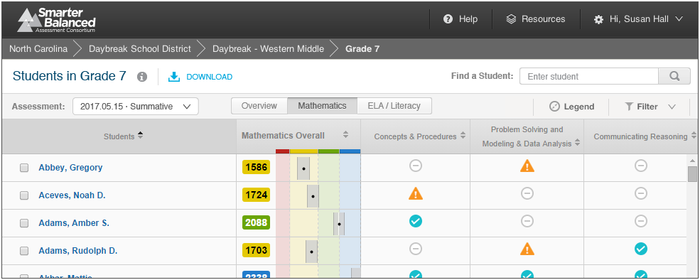

Figure - Mathematics overall and claim scores

**Informational Popup Windows**

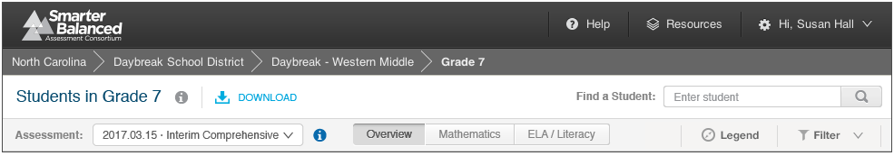

Figure - List of Students in a GRADE Information Indicators

Report Information , Interim Information , and Legend are all available by pausing on or clicking the respective icons.

The Report Information popup contains additional information about the purposes and proposed uses of the report. For the List of Students in a GRADE, the text is as follows:

#### Purpose:

This report presents a list of individual student scores for a selected assessment.

#### Uses:

* Use this report to view the assessment results for a class or other sub-group of students, filtered or sorted for your specific needs.
* Review scale scores and error bands for overall student performance on a specific assessment.
* View claim score icons to understand students’ performance for each claim.

#### Features:

* Select assessment and content area(s) to view
* Sort results by any column
* Select specific students to focus your review
* Search for particular students
* Filter students by attributes (e.g., Gender, IEP, Economic Disadvantage)
* Download student assessment results for further analysis
* Print Individual Student Reports (PDF) for a selected group of students

The Interim Information popup contains specific information about the nature of the interim assessment and suggests appropriate ways to interpret interim results. The text is as follows:

Important Information about Interim Assessments

* Questions on interim tests that require human scoring may be scored locally by teachers. This local scoring is not subject to the rigorous controls used in summative assessment and local results may show some variations.
* Interim assessment questions are not secure. Exposure to, and familiarity, with test questions may affect student performance and the accuracy of interim results.

The legend provides descriptions of all pictorial elements of the report, including Achievement Levels, Error Bands, Claim Levels, and the scale bar. It appears as follows:

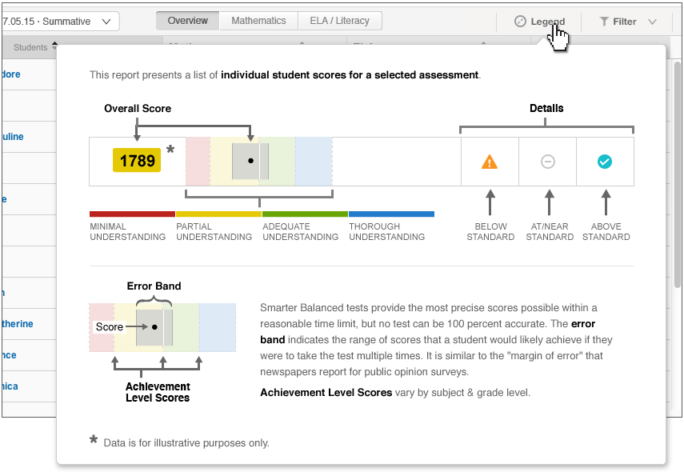

Figure - List of Students in a GRADE Legend

**Downloads**

Download options are available by clicking the **Download** icon Macintosh HD:Users:jkenlon:Desktop:nav_icons.png. There are several options for downloading information through the List of STUDENTS in a GRADE report:

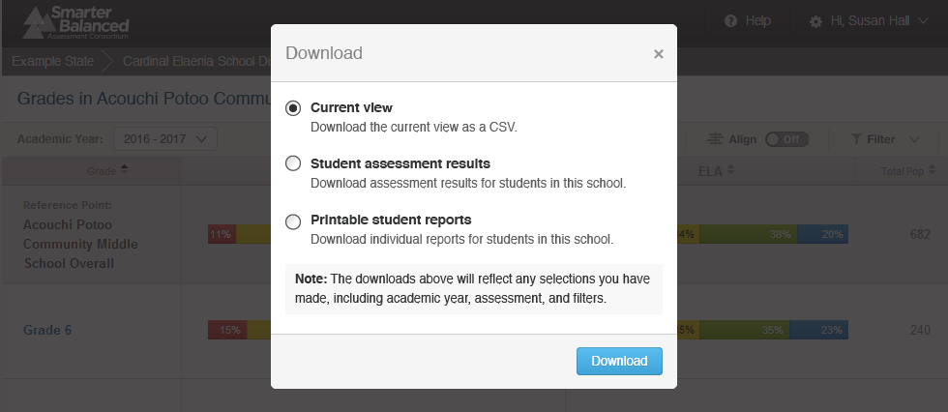

Figure - Download Options Window

* 1 - Current View: All users with access to this report can download a tabular version of the current view of summary data (students, scores, and achievement levels, including any active filters, sorting, or selection) in CSV format for accessibility or external analysis.
* 2 - Student Assessment Results: A user with appropriate permissions can download the underlying Student Assessment Results for the students displayed on the report.
* 3 - Printable Student Reports: A user with appropriate permissions can download a batch PDF of Individual STUDENT Reports for the students displayed on the report.

**Locating Specific Students**

A user can use the Filtering, Sorting, and Find features to locate specific students, and the Selection feature to narrow focus onto any selected students.

**Sorting** - Sort the table by any column ascending or descending: alphabetically by student last name, by Overall scale scores, or by claim levels.

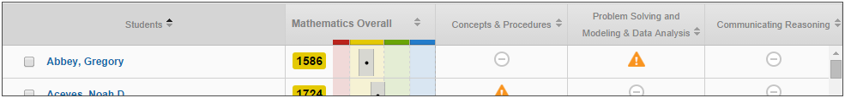

Figure - List of Students in a GRADE Sorting

**Filtering** - Filter the student list by student attributes:

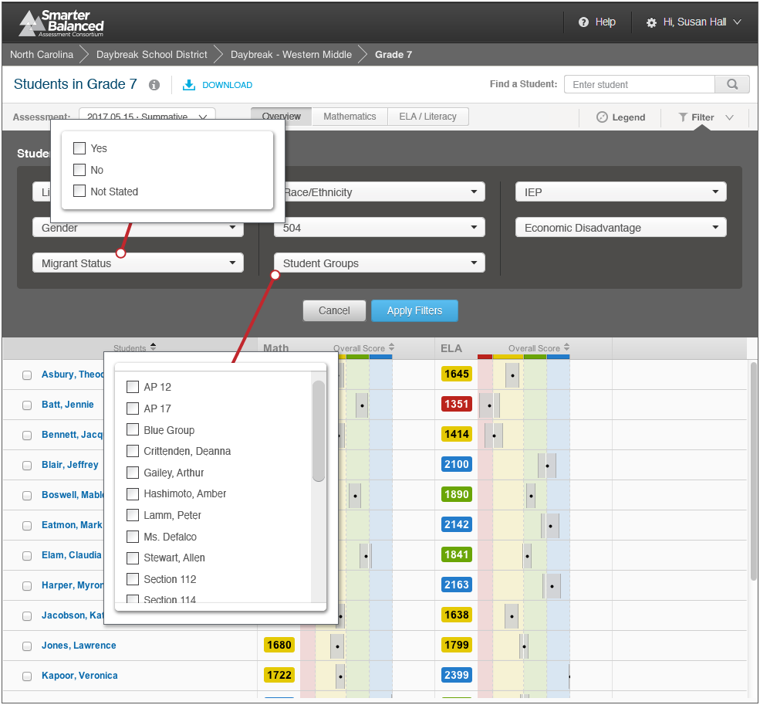



Figure - List of Students in a GRADE Filter Options

Selecting multiple options in a filter (e.g., AP 12 and Blue Group) returns a list composed of any students in either group (OR selection or Union). Selecting options in more than one filter (e.g., AP 12 and Yes under Migrant Status) returns a list of students who fit into both groups (AND selection or Intersection).

**Find a Student** - A user can click the Find box or use the browser **Find** command (Ctrl+F), to type in a part or whole name of a student. The report scrolls down to the first entry matching the search string and provides controls to navigate through any matching entries.

**Select Specific Students** - Each student in the list has a checkbox next to their name to narrow the list. A user can select specific students to compare them to one another or print them out in a batch.

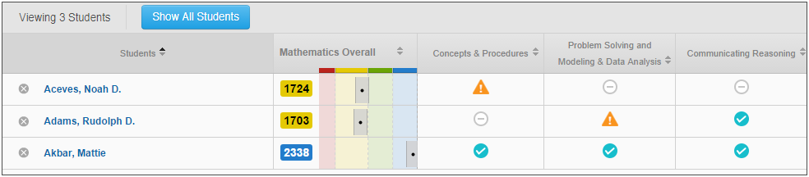

Figure - List of Students in a GRADE Selection

**Printing**

The report as displayed can be printed directly by the built-in browser **Print** command (Ctrl+P). The List of Students in a GRADE report also provides the ability to download the underlying Individual STUDENT Reports in a batch PDF file for bulk printing (see Downloads).

**Language Support**

The textual content of the Reporting System is available for viewing and printing in English by default, but users can select to view or print the content in either Spanish or Vietnamese.

**Student Privacy**

This report contains student personally identifiable information (PII). Therefore, only users with authorization and system permissions to access PII for this student can view this report. Authorization and permissions are set by each state and passed to the Reporting System when a user logs in to the system.

1. In order to see a given Individual STUDENT Report, a user must meet these three requirements:
   * Have appropriate external authorization to access PII
   * Be authenticated through the Smarter Balanced operational Single Sign-On component
   * Have appropriate permissions assigned to their user account through the Smarter Balanced Permissions component
2. PII access permissions are defined at the school level or above and managed through the Smarter Balanced Single Sign-On component and the Permissions component.
3. This report is available in either of the two following cases:
   * In the Consortium-level system, if a given state has provided the Consortium with student PII (i.e., names); or
   * In a state-operated reporting system, if that state has deployed their own instance of the Smarter Balanced Reporting and Data Warehouse solution and provided the system with the above-mentioned data.
4. The reporting system does not display links between teachers and students. This prevents any automated reporting on a teacher, class or section level.
5. To display this report in a state-operated reporting system, the state would need to deploy its own instance of the Smarter Balanced Reporting and Data Warehouse solution and provide the system with the above-mentioned data.
6. The data that drive the List of Students in a GRADE reports, including overall (scale score, error band, and achievement level) and claim (scale score, error band, and claim level) data, are calculated by the Test Integration component and passed to the Data Warehouse. Neither the Reporting System nor the Data Warehouse calculate or compute scores, error bands, or performance levels.

### Results by Grade for a SCHOOL

This report provides a list of grades for a given school, with multi-colored bars that represent the different achievement levels. The percentages of students performing at each level appear as numbers in the bars, and the number of students assessed appears next to the bars. This report also displays the overall aggregate of all the assessed students in the school.

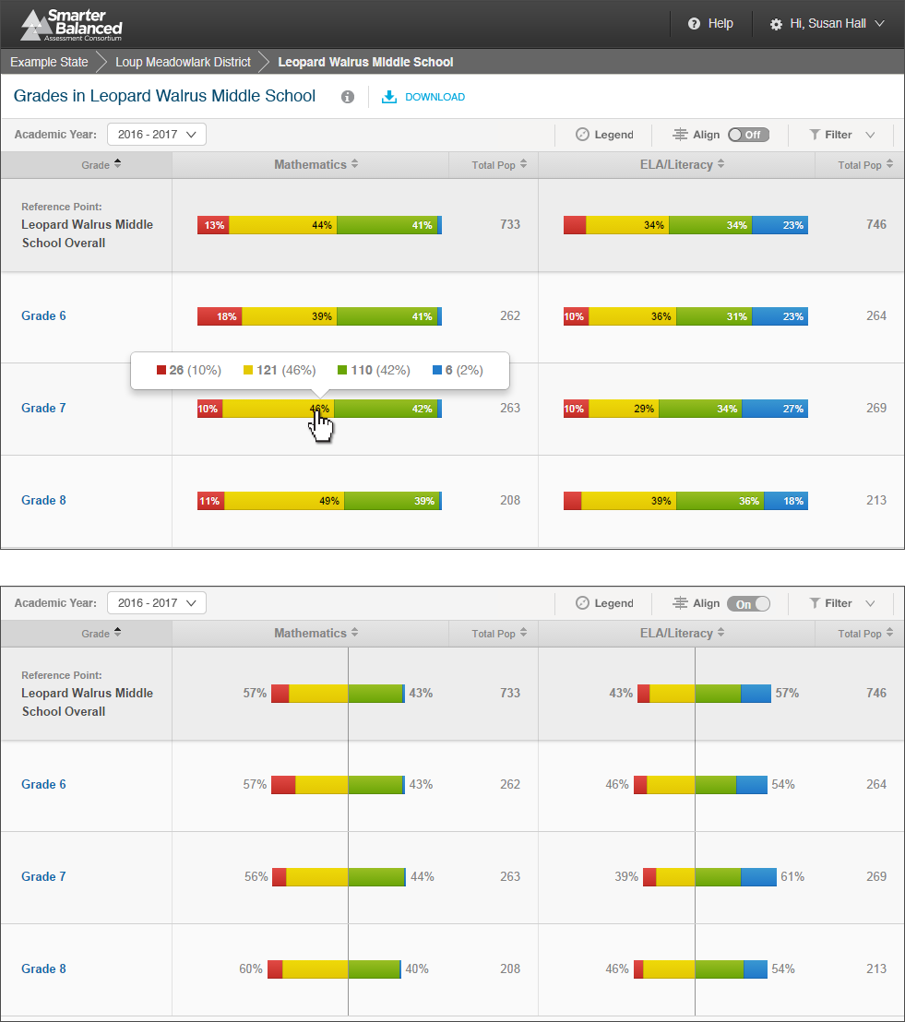

Figure - Results by Grade for a SCHOOL

#### Report Features

|  |  |
| --- | --- |
|  | **Breadcrumbs**: At the top of the page, users can navigate back to the district and state level reports. |
|  | **Report Information**: Detailed report information regarding the report’s purpose and its prospective uses is accessible by pausing on or clicking the “i” information icon next to the report’s title. |
|  | **Download**: The **Download** button allows users to download the current page as a CSV file, or to download the underlying data for analysis. |
|  | **Academic Year Selector**: This dropdown list displays all academic years for which there is available assessment data. |
|  | **Align**: The **Align** switch allows users to display results centered along the cut between achievement levels 2 and 3. |
|  | **Filter**: The **Filter** button opens a window that enables advanced filtering of student results by student demographic information. |
|  | **Column Sorting**: Column headers allow users to sort the list of grades by the values in each column. |
|  | **Reference Row**: Percentages and counts of students in each achievement level across the entire school. |
|  | **Achievement Level Aggregates**: Percentages and actual counts of students in each achievement level for each grade. Users can pause on the information to display the actual counts of students in each achievement level. |

#### Detailed Descriptions

**Navigation**

* A user with appropriate permissions can access the Results by Grade for a SCHOOL report by clicking the school’s name in the Comparing Schools in a DISTRICT report.
* A user can access the Results by Grade for a SCHOOL report by clicking the school’s name in the Breadcrumb Navigation of an Individual STUDENT Report or a List of Students in a GRADE report.
* A user can go back up to the DISTRICT or STATE reports by following the breadcrumbs on top.

****

Figure - Breadcrumb Navigation

* Users do not need PII access to see the Results by Grade for a SCHOOL report, but they must have PII access for the List of Students in a GRADE report. Therefore, a user with PII access can click Grade names to see the list of students in that grade, but a user without PII access is provided with those links.

**Selecting Assessment Results**

* A user can see results for the summative assessment for any academic year for which there are available results via the Academic Year Selector. The options in the Academic Year Selector are based on all assessment results received by the Data Warehouse.
* This report only displays aggregations of summative results, not interim results.
* When a previous academic year is selected, the report displays a warning message saying the results displayed are for a prior academic year’s assessments.

**Informational Popup Windows**

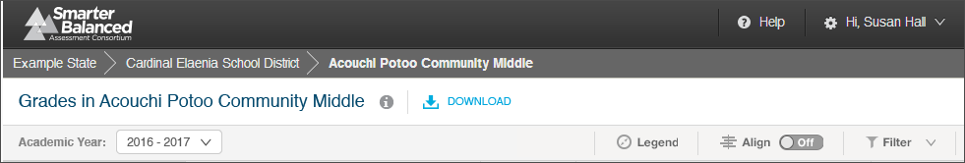

Figure - Results by Grade for a SCHOOL Information Indicators

Report Information and Legend are all available by pausing on or clicking the respective icons.

The Report Information popup contains additional information about the purposes and proposed uses of the report. For the Results by Grade for a SCHOOL report, the text is as follows:

#### Purpose:

This report presents a view of student performance on the most recent summative assessment for each grade in a selected school. For each grade, the report displays the percentage of students in each achievement level and the number of students assessed.

#### Uses:

* Use this report to compare overall achievement between grades in a school.
* Filter the view to analyze sub-groups within a grade.

#### Features:

* Align the visual display by the percentage of students in each achievement level or along the line between Level 2 and Level 3
* Sort results by any column
* Filter results by attributes (e.g., Gender, IEP, Economic Disadvantage)
* Download student assessment results for further analysis
* Print Individual Student Reports (PDF) for all students in the school

The legend provides descriptions of all pictorial elements of the report, including Achievement Levels and the population bar. It appears as follows:

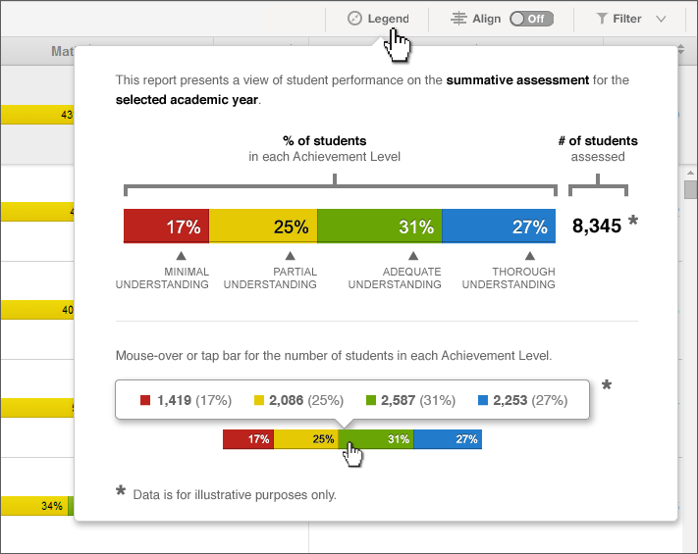

Figure - Results by Grade for a SCHOOL Legend

**Downloads**

Download options are available by clicking the **Download** icon Macintosh HD:Users:jkenlon:Desktop:nav_icons.png. There are several options for downloading information through the Results by Grade for a SCHOOL report:



Figure - Download Options Window

* 1 - Current View: All users with access to this report can download a tabular version of the current view of summary data (achievement levels, including any active filters, sorting, or selection) in CSV format for accessibility or external analysis.
* 2 - Student Assessment Results: A user with appropriate permissions can download the underlying Student Assessment Results for all the grades displayed on the report.
* 3 - Printable Student Reports: A user with appropriate permissions can download a batch PDF of Individual STUDENT Reports of all the students from all the grades displayed on the report.

**Filtering**

A user can filter the results by demographic subgroups for in-depth analysis of their results.

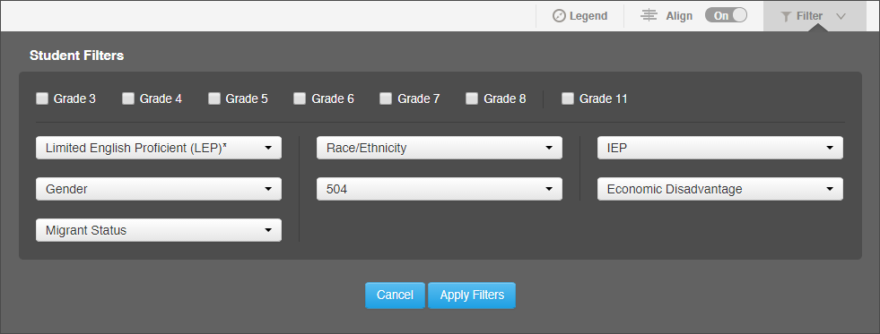

Figure - Results by Grade for a SCHOOL Filter Options

Selecting multiple options in a filter (e.g., Hispanic/Latino and Two or More Races from Race/Ethnicity) returns aggregates composed of any students in either group (OR selection or Union). Selecting options in more than one filter (e.g., Yes under Economic Disadvantage and Yes under Migrant Status) returns a list of students who fit into both groups (AND selection or Intersection).

**Align**

Achievement Level proportion bars can be either aligned by endpoints, or centered on the cut between levels 2 and 3. A user can click the **Align** button to toggle between the two options.

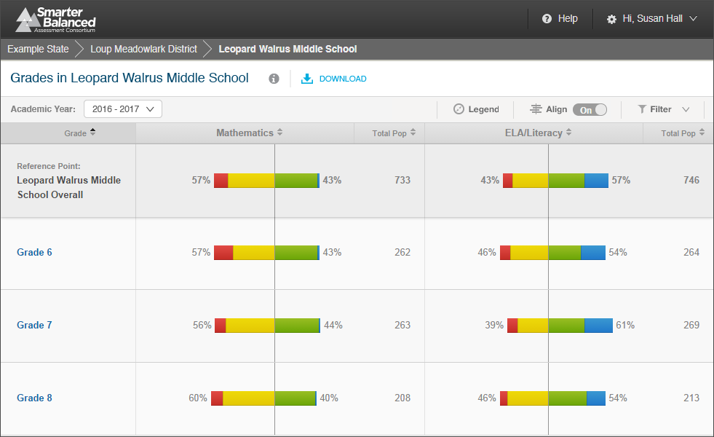

Figure - Align Feature

**Achievement Level Counts**

Pausing on an Achievement Level bar displays numbers of students and percentages by Achievement Level for each level.

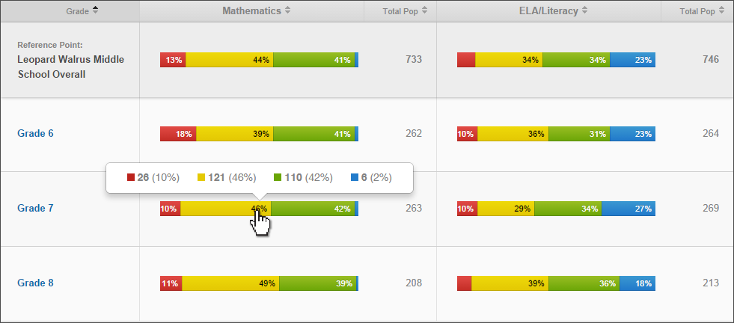

Figure - Student population detail popup window

**Printing**

The report can be printed directly using the built-in browser print command (Ctrl+P). The Results by Grade for a SCHOOL report also provides authorized users the ability to download the underlying Individual STUDENT Reports in a batch PDF file for bulk printing (see Downloads).

**Language Support**

The textual content of the Reporting System is available for viewing and printing in English by default, but users can select to view or print the content in either Spanish or Vietnamese.

**Student Privacy**

This report contains no student personally identifiable information (PII). However, two rules have been instituted to protect student privacy on aggregate reports:

**Minimum Population Size** - States can configure a minimum population size for protecting privacy. If the number of students in an aggregate is lower than the minimum, users without PII authorization see this message: “Data suppressed to protect student privacy.” By default, the minimum number is set to 11.

**Low Performance -** If all students in an aggregate have scored in Level 1 or 2, then users without PII authorization see this message: “Data suppressed to protect student privacy.”

Authorization and permissions are set by each state and passed to the Reporting System when a user logs in to the system.

### Comparing Schools in a DISTRICT

This report provides a list of schools for a given district and compares the academic achievement of students in each school to the district as a whole and to other schools in the district. Multi-colored bars display the percentage of assessed students in each achievement level on the most recent summative assessment, and the total number of students assessed in each school and in the district as a whole.

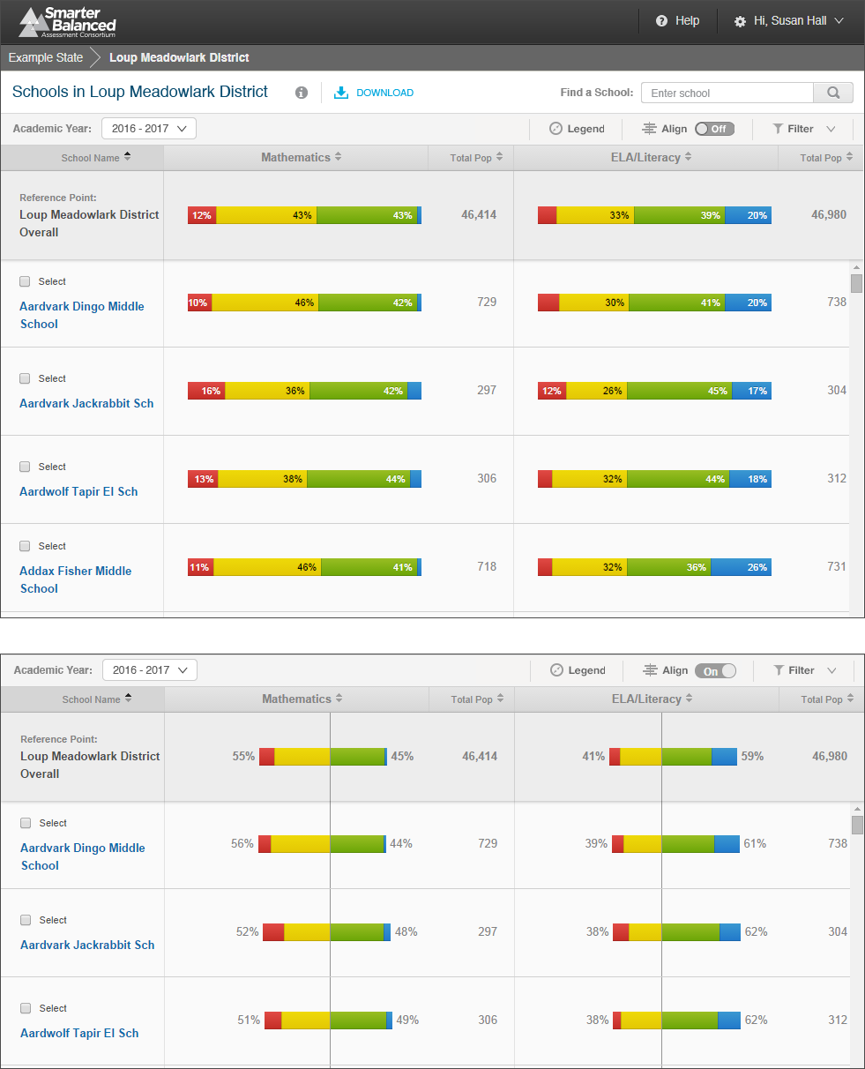

Figure - Comparing Schools in a DISTRICT

#### Report Features

|  |  |
| --- | --- |
|  | **Breadcrumbs**: At the top of the page, users can navigate back to the state level report. |
|  | **Report Information**: Detailed report information regarding the report’s purpose and its prospective uses is accessible by pausing on or clicking the “i” information icon next to the report’s title. |
|  | **Download**: The **Download** button allows users to save the current page as a CSV file, or to download the underlying data for analysis. |
|  | **Academic Year Selector**: A dropdown list of all academic years for which there is available assessment data. |
|  | **Align**: The **Align** switch allows users to display results centered along the cut between achievement levels 2 and 3. |
|  | **Filter**: The **Filter** button opens a window that enables advanced filtering of student results by student demographic information. |
|  | **Column Sorting**: Column headers allow users to sort the list of grades by the values in each column. |
|  | **Reference Row**: Percentages and counts of students in each achievement level across the entire school. |
|  | **Select a School**: Checkboxes next to school names allow users to select specific schools for comparison or printing. Deselect All removes the selection. |
|  | **Achievement Level Aggregates**: Percentages and actual counts of students in each achievement level for each grade. Users can pause on the information to display the actual counts of students in each achievement level. |

#### Detailed Descriptions

**Navigation**

* A user with appropriate permissions can access the Comparing Schools in a DISTRICT report by clicking the district’s name in the Comparing Districts in a STATE report.
* A user can access the Comparing Schools in a DISTRICT report by clicking the school’s name in the breadcrumb navigation of an Individual STUDENT Report, List of Students in a GRADE report or Results by Grade for a SCHOOL report.
* A user can navigate from the Comparing Schools in a DISTRICT report to any Results by Grade for a SCHOOL report by clicking the school’s name.
* A user can to navigate back to the STATE report using the breadcrumbs on top.

****

Figure - Breadcrumb Navigation

* Users do not need PII access in order to see the Comparing Schools in a DISTRICT report, but they must be authorized by their state to see the results in a specific district.

**Selecting Assessment Results**

* A user can see results for the summative assessment for any academic year for which there are available results via the Academic Year Selector. The options in the Academic Year Selector are based on all assessment results received by the Data Warehouse.
* This report **only** displays aggregations of summative results, not interim results.
* When a previous academic year is selected, the report displays a warning message alerting users that the results displayed are for a prior academic year’s assessments.

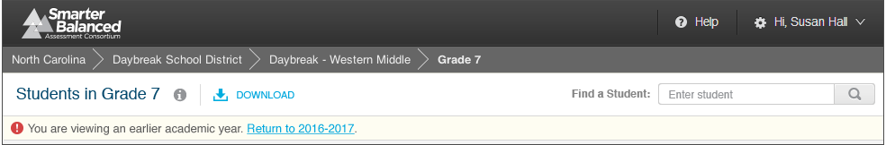

Figure - Previous Year Warning Message

**Informational Popup Windows**

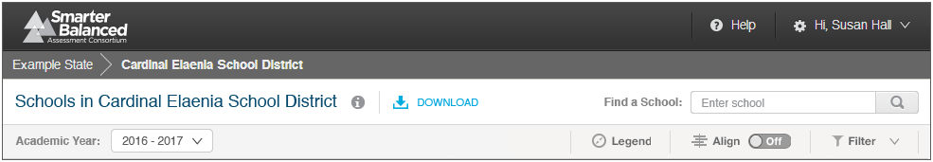

Figure - Comparing Schools in a DISTRICT Information Indicators

Report Information and Legend are available by pausing on or clicking the respective icons.

The Report Information popup contains additional information about the purposes and proposed uses of the report. For the Comparing Schools in a DISTRICT report, the text is as follows:

#### Purpose:

This report presents a view of student performance on the most recent summative assessment for each school in a selected district. For each school, the report displays the percentage of students in each achievement level and the number of students assessed.

#### Uses:

* Use this report to compare overall school achievement within a district.
* Filter the view to analyze sub-groups within schools.

#### Features:

* Align the visual display by the percentage of students in each achievement level or along the line between Level 2 and Level 3
* Sort results by any column
* Filter results by attributes (e.g., Gender, IEP, Economic Disadvantage)
* Download student assessment results for further analysis

The legend provides descriptions of all pictorial elements of the report, including Achievement Levels and the population bar. It appears as follows:



Figure - Comparing Schools in a DISTRICT Legend

**Downloads**

Download options are available by clicking the **Download** icon Macintosh HD:Users:jkenlon:Desktop:nav_icons.png. There are several options for downloading information through the Comparing Schools in a DISTRICT report:



Figure - Download Options Window

* 1 - Current View: All users with access to this report can download a tabular version of the current view of summary data (achievement levels, including any active filters, sorting, or selection) in CSV format for accessibility or external analysis.
* 2 - Student Assessment Results: A user with appropriate permissions can download the underlying Student Assessment Results of all the schools displayed on the report.
* 3 - Printable Student Reports: This selection is not available at this level and appears dimmed.

**Locating Specific Schools**

**Sorting** - A user can sort on any of the columns (school Name, mathematics overall results, number of students assessed in mathematics, ELA/literacy overall results, and number of students assessed in ELA/literacy). A single click sorts either alphabetically (for name) or from lowest to highest, and a second click reverses the sort order.

**Filtering** - A user can filter the results by demographic subgroups for in-depth analysis of those results.



Figure - Results by Grade for a SCHOOL Filter Options

Selecting multiple options in a filter (e.g., Hispanic/Latino and Two or More Races from Race/Ethnicity) returns aggregates composed of any students in either group (OR selection or Union). Selecting options in more than one filter (e.g., Yes under Economic Disadvantage and Yes under Migrant Status) returns a list of students who fit into both groups (AND selection or Intersection).

**Find a School** - A user can click into the Find box, or use the browser “find” command (Ctrl+F), to type in a part or whole name of a school. The report scrolls down to the first entry matching the search string and provides controls to navigate through any matching entries.

**Select specific schools** - Each school in the list has a checkbox next to its name to narrow the list. A user can select specific schools to compare them to one another or create a custom list for downloading or printing.

**Align**

Achievement Level proportion bars can be either aligned by endpoints, or centered on the cut between levels 2 and 3. A user can click the **Align** button to toggle between the two options.

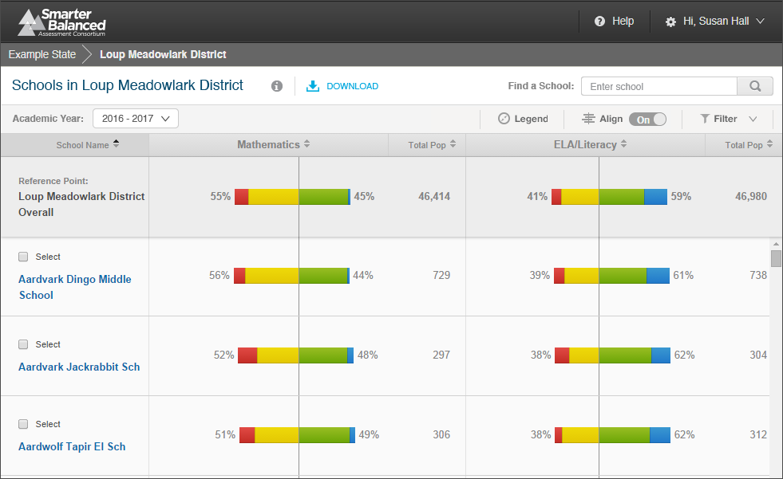

Figure - Align Feature

**Achievement Level Counts**

Pausing on an Achievement Level bar displays numbers of students and percentages by Achievement Level for each level.

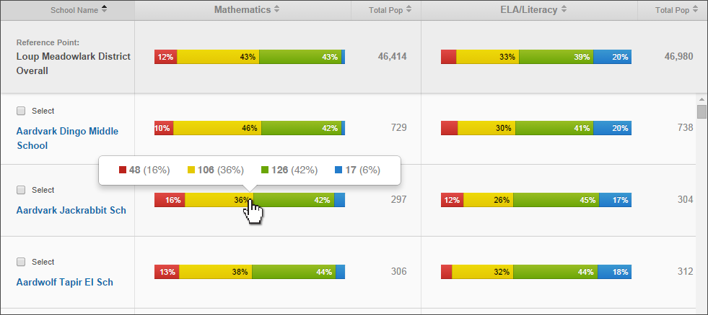

Figure - Student population detail popup window

**Printing**

The report as displayed can be printed directly using the built-in browser print command (Ctrl+P).

**Language Support**

The textual content of the Reporting System is available for viewing and printing in English by default, but users can select to view or print the content in either Spanish or Vietnamese.

**Student Privacy**

This report contains no student personally identifiable information (PII). However two rules have been instituted to protect student privacy on aggregate reports:

**Minimum Population Size** - States can configure a minimum population size for protecting privacy and if the number of students in an aggregate is lower than the minimum, users without PII authorization see this message: “Data suppressed to protect student privacy.” By default, the minimum number is set to 11.

**Low Performance -** If all students in an aggregate have scored in Level 1 or 2, then users without PII authorization see this message: “Data suppressed to protect student privacy.”

Authorization and permissions are set by each state and passed to the Reporting System when a user logs in to the system.

### Comparing Districts in a STATE

This report provides a list of districts for a given state and compares the academic achievement of students in each district to the state as a whole and to other districts in the state. Multi-colored bars display the percentage of assessed students in each achievement level on the most recent summative assessment, and the total number of students assessed in each district and in the state as a whole.

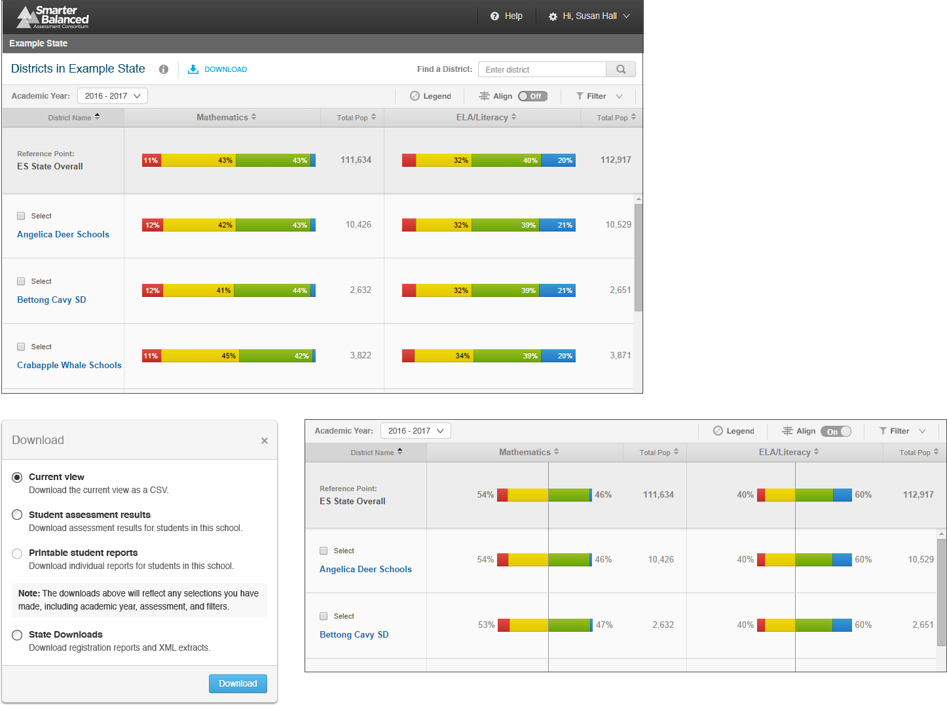

Figure - Comparing Districts in a STATE

#### Report Features

|  |  |
| --- | --- |
|  | **Report Information**: Detailed report information regarding the report’s purpose and its prospective uses is accessible by pausing on or clicking the “i” information icon next to the report’s title. |
|  | **Download**: The **Download** button allows users to save the current page as a CSV file, or to download the underlying data for analysis. |
|  | **Academic Year Selector**: A dropdown list of all academic years for which there is available assessment data. |
|  | **Align**: The **Align** switch allows users to display results centered along the cut between achievement levels 2 and 3. |
|  | **Filter**: The **Filter** button opens a window that enables advanced filtering of student results by student demographic information. |
|  | **Column Sorting**: Column headers allow users to sort the list of districts by the values in each column. |
|  | **Reference Row**: Percentages and counts of students in each achievement level across the entire district. |
|  | **Select a District**: Checkboxes next to district names allow users to select specific districts for comparison or printing. “Deselect All” removes the selection. |
|  | **Achievement Level Aggregates**: Percentages and actual counts of students in each achievement level for each district. Users can pause on the information to display the actual counts of students in each achievement level. |

#### Detailed Descriptions

**Navigation**

* A properly permissioned state user can see the Comparing Districts in a STATE report for his or her state after logging in to the Data Warehouse and Reporting System.
* A user can access the Comparing Schools in a DISTRICT report by clicking the school’s name in the breadcrumb navigation of an Individual STUDENT Report, List of Students in a GRADE report, Results by Grade for a SCHOOL report, or Comparing Schools in a DISTRICT report.
* A user can navigate from the Comparing Districts in a STATE report to any Comparing Schools in a DISTRICT report by clicking the district’s name.
* Users do not need PII access in order to see the Comparing Districts in a STATE report, but they must be authorized by their state to see state results.

**Selecting Assessment Results**

* A user can see results for the summative assessment for any academic year for which there are available results via the Academic Year Selector. The options in the Academic Year Selector are based on all assessment results received by the Data Warehouse.
* This report only displays aggregations of summative results, not interim results.
* When a previous academic year is selected, the report displays a warning message alerting users that the results displayed are for a prior academic year’s assessments.

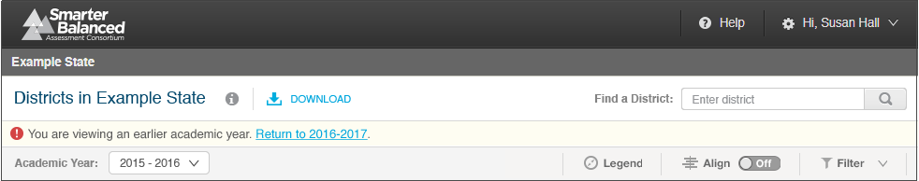

Figure - Previous Year Warning Message

**Informational Popup Windows**

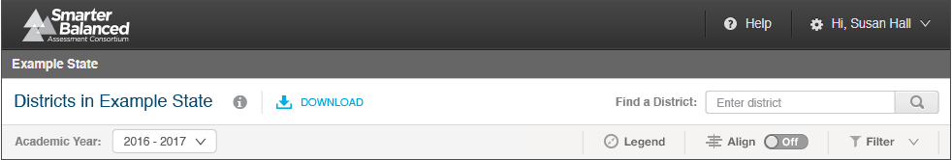

Figure - Comparing Schools in a DISTRICT Information Indicators

Report Information and Legend are all available by pausing on or clicking the respective icons.

The Report Information popup contains additional information about the purposes and proposed uses of the report. For the Comparing Districts in a STATE report, the text is as follows:

#### Purpose:

This report presents a view of student performance on the most recent summative assessment for each district in a state. For each district, the report displays the percentage of students in each achievement level and the number of students assessed.

#### Uses:

* Use this report to compare overall district achievement within a state.
* Filter the view to analyze sub-groups within districts.

#### Features:

* Align the visual display by the percentage of students in each achievement level or along the line between Level 2 and Level 3
* Sort results by any column
* Filter results by attributes (e.g., Gender, IEP, Economic Disadvantage)
* Download student assessment results for further analysis

The legend provides descriptions of all pictorial elements of the report, including Achievement Levels and the population bar. It appears as follows:

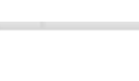



Figure - Comparing Schools in a DISTRICT Legend

**Downloads**

Download options are available by clicking the **Download** icon Macintosh HD:Users:jkenlon:Desktop:nav_icons.png. There are several options for downloading information through the Comparing Districts in a State report:

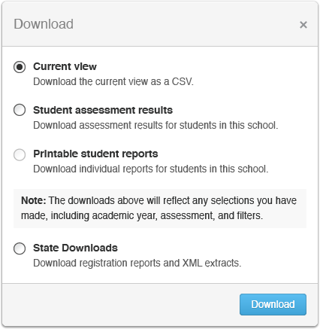

Figure - Download Options Window

* Current View: All users with access to this report can download a tabular version of the current view of summary data (achievement levels, including any active filters, sorting, or selection) in CSV format for accessibility or external analysis.
* Student Assessment Results: A user with appropriate permissions can download the underlying Student Assessment Results for all the schools displayed on the report.
* Printable Student Reports: This option is not available at this level and appears dimmed.
* State Downloads: A user with appropriate permissions can request state-level downloads (see below for further description).

**Locating Specific Districts**

**Sorting** - A user can sort on any of the columns (school name, mathematics overall results, number of students assessed in mathematics, ELA/literacy overall results, number of students assessed in ELA/literacy). A single click sorts either alphabetically (for name) or from lowest to highest, and a second click reverses the sort order.

**Filtering** - A user can filter the results by demographic subgroups for in-depth analysis of results.

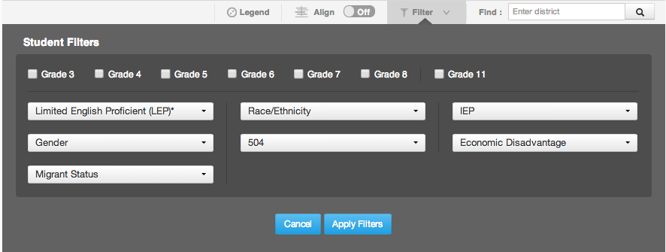

Figure - Results by Grade for a SCHOOL Filter Options

Selecting multiple options in a filter (e.g., Hispanic/Latino and Two or More Races from Race/Ethnicity) returns aggregates composed of any students in either group (OR selection or Union). Selecting options in more than one filter (e.g., Yes under Economic Disadvantage and Yes under Migrant Status) returns a list of students who fit into both groups (AND selection or Intersection).

**Find a District** - A user can click into the Find box or use the browser **Find** command (Ctrl+F) to type in a part or whole name of a district. The report scrolls down to the first entry matching the search string and provides controls to navigate through any matching entries.

**Select Specific Districts** - Each district in the list has a checkbox next to its name to narrow the list. A user can select specific districts to compare them to one another or create a custom list for downloading or printing.

**Align**

Achievement Level proportion bars can be either aligned by endpoints or centered on the cut between levels 2 and 3. A user can click the **Align** button to toggle between the two options.

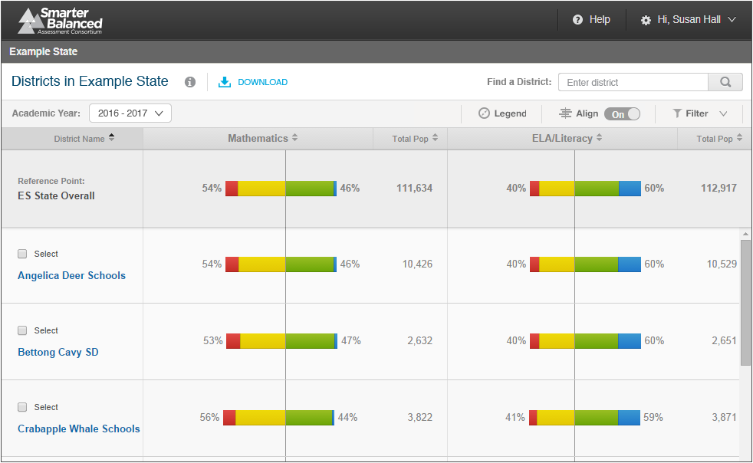

Figure - Align Feature

**Achievement Level Counts**

Pausing on an Achievement Level bar displays numbers of students and percentages by Achievement Level for each level.

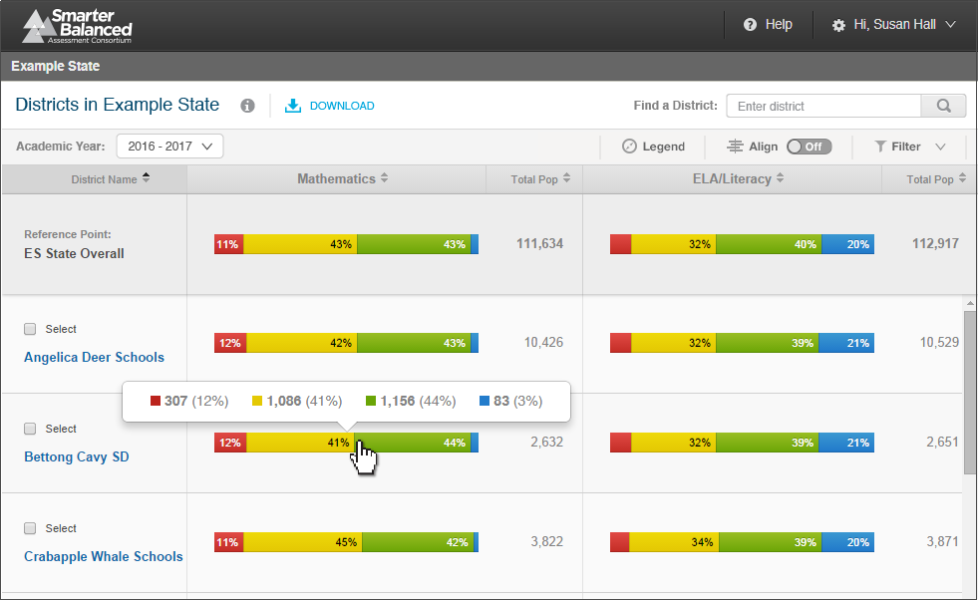

Figure - Student population detail popup window

**Printing**

The report as displayed can be printed directly using the built-in browser print command (Ctrl+P).

**Language Support**

The textual content of the Reporting System is available for viewing and printing in English by default, but users can select to view or print the content in either Spanish or Vietnamese.

**Student Privacy**

This report contains no Student personally identifiable information (PII). However two rules have been instituted to protect student privacy on aggregate reports:

**Minimum Population Size** - States can configure a minimum population size for protecting privacy, and, if the number of students in an aggregate is lower than the minimum, users without PII authorization see this message: “Data suppressed to protect student privacy.” By default, the minimum number is set to 11.

**Low Performance -** If all students in an aggregate have scored in Level 1 or 2, then users without PII authorization see this message: “Data suppressed to protect student privacy.”

Authorization and permissions are set by each state and passed to the Reporting System when a user logs in to the system.

## Data Downloads

In addition to the predesigned reports, the reporting system offers authorized users the ability to download data for distribution or further review and analysis in external systems.

This section describes the different types of downloads in detail.

|  |  |
| --- | --- |
| **ID** | **Download Name** |
| 1.2.1 | Student Assessment Results |
| 0 | List of Students in a GRADE |
| 1.2.3 | State Downloads: Overview |
| 1.2.4 | State Download: Student Registration Statistics |
| 1.2.5 | Comparing Districts in a STATE |
| 1.2.6 | State Download: Audit XML |
| 1.2.7 | State Download: Individual Item Response Data |

Table - List of Data Downloads

### Student Assessment Results

#### Description

This is a bulk download of the assessment results, with one row per student-assessment. The resulting files contain all of the data for Overall and Claim scores (e.g., scale score, error band, level determination), as well as all the student data (e.g., demographics, grade/school/district/state attribution, etc.)

This download may be requested by a state administrator as a statewide bulk extract, but is also implemented for Educators and Administrators with PII access, at the DISTRICT, SCHOOL, and GRADE levels.

#### Assessments

This download is available for summative and interim comprehensive assessments.

#### Primary Audiences

This download is primarily intended for state administrators, district administrators, principals, and teachers.

#### Navigation

Users who are authorized and have the proper permissions can request this download through the Download interface.

#### Features

* This download is supported at the STATE, DISTRICT, SCHOOL, and GRADE level; the two lowest levels are executed synchronously, while the larger downloads for district and state leverage the HTTPS Pickup Zone.
* This download request generates file pairs for each assessment, where a summative assessment is defined by Academic Year, Grade, and Subject, and an interim comprehensive assessment is defined by the Academic Year, Grade, Subject, and administration window.
* The file pair is composed of 1) a large CSV containing all of the assessment results data directly reported on by the Reporting System and 2) a JSON metadata file that includes all repetitive data common to all assessment results.

#### PII Protection

* Access to the Download interface is restricted to authorized users with the proper system permissions. Requests may be made via the user interface or by a system-to-system API call.
* Once a request is made, the process is asynchronously executed and the output uploaded to the HTTPS Pickup Zone, where it can be retrieved by the requesting user.
* All SCHOOL and GRADE extracts are protected by PII access rules.

#### Data Summary

The Student Assessment Results data specification format is published in detail to:

<http://www.smarterapp.org/documents/DataWarehouse-Spec-StudentAssessments.pdf>

### Printable Student Reports

This download option is available from the List of Students in a GRADE report and the Results by Grade in a SCHOOL report. The option is disabled on the Comparing Schools in a DISTRICT report and the Comparing Districts in a STATE report.

**Purpose**

The purpose of this download is to provide educators with the ability to download and print batches of individual student reports at once. This feature enables a teacher to print out all of or some of his or her students’ individual student reports and a school administrator to print out an entire school’s individual student reports at once. For summative and interim comprehensive assessment results, a student’s report is approximately three pages; one page for mathematics, one page for ELA/literacy, and one page for reference material, e.g. Report Information and Legend.

**Navigation**

A user would select the **Printable Student Reports** option from the Download popup window.

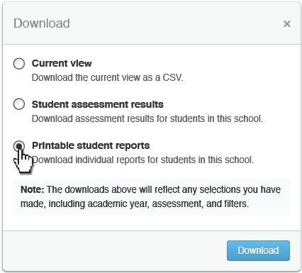

Figure - Download Popup Window

The system then displays a second popup window that requires users to specify whether they want to print out in grayscale or color and whether they want the reports to print out in English, Spanish, or Vietnamese (Design TBD).

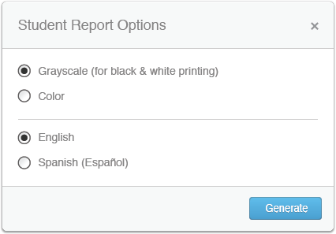

Figure - Download Printable Student Report Options

A status window then tells users an email will notify them when the file is ready and provide them with a secure URL at which to download it.

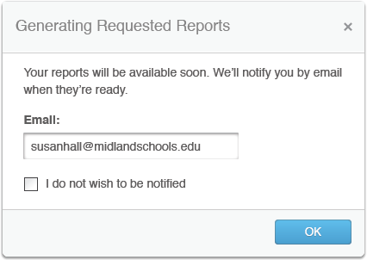

Figure - Download Confirmation Window

Clicking the URL allows the user to download a zip file with the requested individual student reports in PDF format. When the user opens the file, the first page includes the name of the school, grade, number of pages, number of students, name of requestor, and date.



Figure - Printable Student Reports Cover Page

**Size Constraints**

In the event that a single batch request contains more than 1,000 students, it is divided into separate files that are made available to the user to download. Each PDF starts with a cover page that includes all the above information, but also indicates how the system has divided the request into files, the place of each file within the larger batch (e.g., Part 1 of 3), and the names of the first and last student in this file.



Figure - Printable Student Reports Segment Cover Page

### State Downloads: Overview

For users with the appropriate state-level permissions, the system displays the **State Downloads** option in the Download popup window.

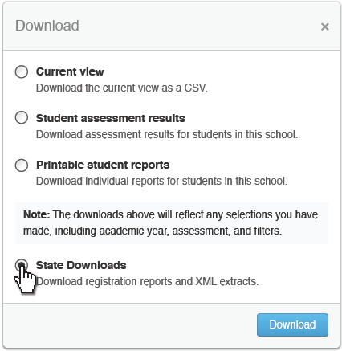

Figure - Download Popup Window

When selected, this option presents the user with a second popup window.

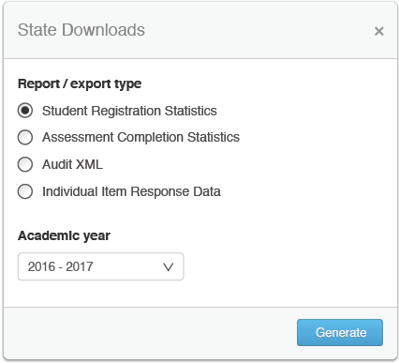

Figure - State Download selector

Each of these options is discussed in detail below.

### State Download: Student Registration Statistics

#### Description

This download provides a registering entity (i.e., a state or district) with a list of current year registration statistics, previous year registration statistics, and the differences between them, broken down by district and school. This should enable the registering entity to discern broad shifts in registration patterns and determine if there were errors in the current year’s registration process.

#### Assessments

This download shows statistics of registration records for a specified academic year and compares them to those of previous years. Registration records are not constrained by assessment types.

#### Primary Audiences

This download is primarily intended for Consortium, state, and district administrators.

#### Navigation

Users who are authorized and have proper permissions can request this download through the Download interface by selecting **Student Registration Statistics**, an academic year, and clicking the **Generate** button.

A status window then tells users an email will notify them when the file is ready and provide them with a secure URL at which to download the file.



Figure - Download Confirmation Window

#### Features

* This download provides a list of districts and schools for a given data tenant, with columns for previous year data, current year data, and the difference between them. Data include overall counts, percentages, and deltas for all demographic and program attributes used for disaggregation.
* Users can see if the differences between the previous and the current year fall within acceptable parameters for their state or district.
* Users can then correct data errors in the source registration system.

#### PII Protection

* Access to the Download interface is restricted to authorized users with the proper system permissions. Requests may be made via the user interface or by a system-to-system API call.
* Once a request is made, the process is asynchronously executed and the output uploaded to the HTTPS Pickup Zone, where it can be retrieved only by the requesting user.
* After a certain number of days (configurable by state), the retrieval URL is disabled.

#### Data Summary

The Student Registration Statistics download includes summary data for each school, district, and the state.

For a download summary for the 2016 Academic Year, the columns calculated based on Student Registration data are:

* State
* District
* School
* Category\*
* Value\*
* AY2015 Count
* AY2015 Percent of Total
* AY2016 Count
* AY2016 Percent of Total
* Change in Count
* Percent Difference in Count
* Change in Percent of Total
* AY2016 Matched IDs to AY2015 Count
* AY2016 Matched IDs Percent of AY2015 Count

\* - Category and Value define disaggregates of interest, resulting in 28 rows per school, district, and state:

| **Category** | **Value** |
| --- | --- |
| Total | Total |
| Sex | Male |
| Sex | Female |
| Ethnicity | HispanicOrLatinoEthnicity |
| Race | AmericanIndianOrAlaskaNative |
| Race | Asian |
| Race | BlackOrAfricanAmerican |
| Race | NativeHawaiianOrOtherPacificIslander |
| Race | White |
| Race | DemographicRaceTwoOrMoreRaces |
| Program | IDEAIndicator |
| Program | LEPStatus |
| Program | 504Status |
| Program | EconomicDisadvantageStatus |
| Program | MigrantStatus |
| Grade KG | Total |
| Grade 01 | Total |
| Grade 02 | Total |
| Grade 03 | Total |
| Grade 04 | Total |
| Grade 05 | Total |
| Grade 06 | Total |
| Grade 07 | Total |
| Grade 08 | Total |
| Grade 09 | Total |
| Grade 10 | Total |
| Grade 11 | Total |
| Grade 12 | Total |

Table - Student Registration Statistics disaggregation

#### Assumptions

1. In Year 1, this report does not have previous year data for comparison, so users have to review actual counts and percentages and discount the calculated deltas.
2. Student Registration Statistics does not report on individual anomalies, but rather at the aggregate level for aggregate attributes of interest. Individual registration validation is done by the registering entity at registration time.
3. Data are provided as a downloadable file in CSV format.

### State Download: Assessment Completion Statistics

#### Description

While the Test Delivery System provides real-time assessment progress and completion reporting, the Data Warehouse provides historical reporting on assessment completion. For a specified assessment administration, this download provides counts of registered and assessed students and percentages of students assessed. This enables an administrator to review how many of the registered students have been assessed.

#### Assessments

This download shows completion statistics for summative or interim comprehensive assessments.

#### Primary Audience

This download is intended primarily for Consortium administrators, but may also be used by state and district administrators.

#### Navigation

Users who are authorized and have proper permissions can request this download through the Download interface by selecting **Assessment Completion Statistics**, an academic year, and clicking the **Generate** button.

A status window then tells users an email will notify them when the file is ready and provide them with a secure URL at which to download the file.



Figure - Download Confirmation Window

#### Features

* Users select a state, academic year, and an assessment to generate the file.
* The file provides a list of districts and schools for a given state, with counts for the academic year. Data include overall counts and percentages for all demographic and program attributes used for disaggregation.

#### PII Protection

* Access to the Download interface is restricted to authorized users with the proper system permissions. Requests may be made via the user interface or by a system-to-system API call.
* Once a request is made, the process is asynchronously executed and the output uploaded to the HTTPS Pickup Zone, where it can be retrieved only by the requesting user.
* After a certain number of days (configurable by state), the retrieval URL is disabled.

#### Data Summary

The Assessment Completion Statistics download includes summary data for each school, district, and the state.

For a download summary for the 2016 Academic Year, the columns calculated based on Student Registration data are:

* State
* District
* School
* Category\*
* Value\*
* AY2015 Count of Registered Students
* AY2015 Count of Students Assessed by Summative Math
* AY2015 Percent of Registered Students Assessed by Summative Math
* AY2015 Count of Students Assessed by Summative ELA
* AY2015 Percent of Registered Students Assessed by Summative ELA
* AY2015 Count of Students Assessed by Interim Comprehensive Math
* AY2015 Percent of Registered Students Assessed by Interim Comprehensive Math
* AY2015 Count of Students Assessed by Interim Comprehensive ELA
* AY2015 Percent of Registered Students Assessed by Interim Comprehensive ELA

\* - Category and Value define disaggregates of interest, resulting in 28 rows per school, district, and state:

| **Category** | **Value** |
| --- | --- |
| Total | Total |
| Sex | Male |
| Sex | Female |
| Ethnicity | HispanicOrLatinoEthnicity |
| Race | AmericanIndianOrAlaskaNative |
| Race | Asian |
| Race | BlackOrAfricanAmerican |
| Race | NativeHawaiianOrOtherPacificIslander |
| Race | White |
| Race | DemographicRaceTwoOrMoreRaces |
| Program | IDEAIndicator |
| Program | LEPStatus |
| Program | 504Status |
| Program | EconomicDisadvantageStatus |
| Program | MigrantStatus |
| Grade KG | Total |
| Grade 01 | Total |
| Grade 02 | Total |
| Grade 03 | Total |
| Grade 04 | Total |
| Grade 05 | Total |
| Grade 06 | Total |
| Grade 07 | Total |
| Grade 08 | Total |
| Grade 09 | Total |
| Grade 10 | Total |
| Grade 11 | Total |
| Grade 12 | Total |

Table - Assessment Completion Statistics disaggregation

#### Assumptions

During and shortly after the assessment administration, the Test Delivery System provides “intra-administration” completion reporting, but this reporting system’s completion report extract serves as an historical record.

### State Download: Audit XML

#### Description

For a specified assessment administration, this download provides the original Assessment XML that flows from the Test Delivery System, to the Test Integrator component, through the Test Score Batcher component to the Data Warehouse. This download ensures that all information for a given student assessment is maintained, including usage reports for Universal Tools and Designated Supports, as well as any additional data provided by a Test Delivery System that is not otherwise processed by the Test Score Batcher.

#### Assessments

This download shows item response data for summative or interim comprehensive assessments.

#### Primary Audience

This download is primarily intended for auditing and research.

#### Navigation

Users who are authorized and have proper permissions can request this download through the Download interface by selecting **Audit XML**, an academic year, and clicking the **Generate** button.

The system then expands the window to request additional information. For the Audit XML, users must select a grade, subject and assessment type, as well as the academic year.

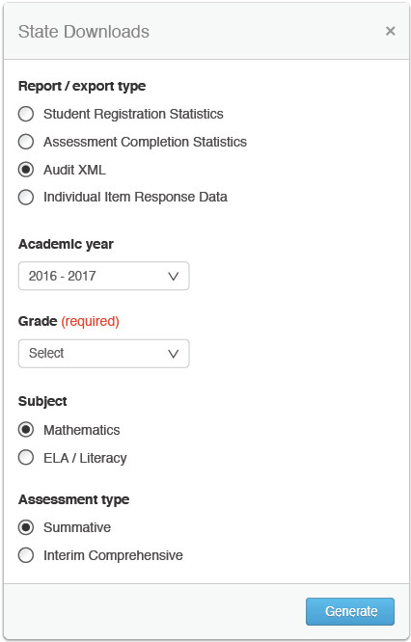

Figure - State Downloads Window

Once the **Generate** button has been clicked, a status window tells users an email will notify them when the file is ready and provide them with a secure URL at which to download the file.



Figure - Download Confirmation Window

#### Features

* Users select a specific assessment to generate the download of all XML for that assessment.

#### PII Protection

* Access to the Download interface is restricted to authorized users with the proper system permissions. Requests may be made via the user interface or by a system-to-system API call.
* Once a request is made, the process is asynchronously executed and the output uploaded to the HTTPS Pickup Zone, where it can be retrieved only by the requesting user.
* After a certain number of days (configurable by state), the retrieval URL is disabled.

#### Data Summary

The Source or Audit XML data specification format is documented by the Test Delivery System vendor, and published to:

<http://www.smarterapp.org/documents/TestResultsTransmissionFormat.pdf>

The structure and contents of every assessment opportunity are maintained and reproduced in full by this download.

### State Download: Individual Item Response Data

#### Description

For a specified assessment administration, this download provides Individual Item Responses to support Consortium psychometricians in performing psychometric analysis and calibration for the platform.

#### Assessments

This download shows item response data for summative or interim comprehensive assessments.

#### Primary Audience

This download is primarily intended for Consortium administrators only, specifically the Consortium psychometrician.

#### Navigation

Users who are authorized and have proper permissions can request this download through the Download interface by selecting **Individual Item Response Data**, an academic year, and clicking the **Generate** button.

The system then expands the window to request additional information. For the Individual Item Response Data, users must select a grade, subject and assessment type, as well as the academic year.

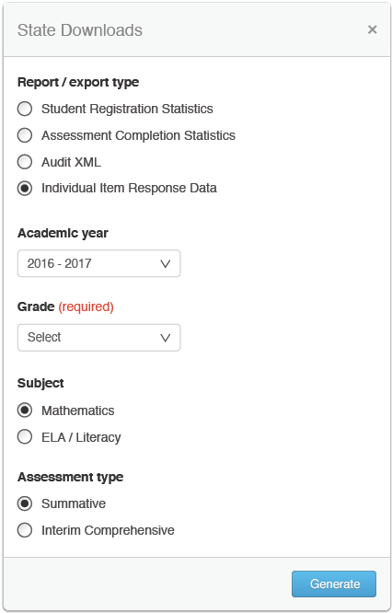

Figure - State Downloads Window

Once the **Generate** button has been clicked, a status window tells users an email will notify them when the file is ready and provide them with a secure URL at which to download the file.



Figure - Download Confirmation Window

#### Features

* Users select a specific assessment to generate the download of all responses for that assessment.

#### PII Protection

* Access to the Download interface is restricted to authorized users with the proper system permissions. Requests may be made via the user interface or by a system-to-system API call.
* Once a request is made, the process is asynchronously executed and the output uploaded to the HTTPS Pickup Zone, where it can be retrieved only by the requesting user.
* After a certain number of days (configurable by state or by the Consortium), the retrieval URL is disabled.

#### Data Summary

The detailed data specification format for Individual Item Response Data is published to:

<http://www.smarterapp.org/documents/DataWarehouse-Spec-ItemLevel.pdf>

| **Name** | **Description** | **Width (chars)** | **Required** | **Acceptable Values** | **Data Type** | **References** |
| --- | --- | --- | --- | --- | --- | --- |
| key | Identifier for an individual item, as set by the Item Authoring system | 40 | Y | 40 alphanumeric characters allowed, expected to be GUID | xsd:token | <https://ceds.ed.gov/CEDSElementDetails.aspx?TermId=3623>  CEDS Element ID 000630 |
| studentID | Identifier for the student (repeated in each row, but will not change within a single file) | 50 | Y | 50 alphanumeric characters allowed | xsd:token | <https://ceds.ed.gov/CEDSElementDetails.aspx?TermxTopicId=20775>  CEDS Element ID 001071 |
| segmentId | Test segment the item was administered on | 250 | Y | 250 alphanumeric characters allowed | xsd:token |  |
| position | Ordinal position of the item on the test |  | N | Positive 32-bit integer, null allowed | xsd:unsignedInt |  |
| clientId | Identifier for an individual item, as set by the client | 80 | Y | 80 alphanumeric characters allowed | xsd:token |  |
| operational | 1 if test item is operational, 0 if test item is field test | 1 | Y | 0, 1 | xsd:boolean |  |
| isSelected | 1 if the student submitted their response for scoring, 0 if they did not | 1 | Y | 0, 1 | xsd:boolean |  |
| format | Type for the given item | 250 | Y | associateInteraction  choiceInteraction  customInteraction  drawingInteraction  endAttemptInteraction  extendedTextInteraction  gapMatchInteraction  graphicAssociateInteraction  graphicGapMatchInteraction  graphicOrderInteraction  hotspotInteraction  hottextInteraction  inlineChoiceInteraction  matchInteraction  mediaInteraction  orderInteraction  positionObjectInteraction  selectPointInteraction  sliderInteraction  textEntryInteraction  uploadInteraction  EBSR  EQ  ER  GI  HT  HTQ  MC  MI  MS  NL  SA  TI  TUT  WER  WORDLIST  Stimulus | xsd:token | <https://ceds.ed.gov/CEDSElementDetails.aspx?TermxTopicId=21603>  CEDS Element ID 001158 |
| score | Number of score points earned by the student, or -1 if the item is not scored |  | Y | Unsigned float, -1 allowed | xsd:float |  |
| scoreStatus | Provided by independent item scoring engine |  | Y | NOTSCORED  SCORED  SCORINGERROR  WAITINGFORMACHINESCORE | xsd:token |  |
| adminDate | Date and time item was administered to student |  | Y | Date + Time | xsd:datetime | <https://ceds.ed.gov/CEDSElementDetails.aspx?TermId=3960>  CEDS Element ID 000959 |
| numberVisits | Number of times the student modified their response to the item |  | Y | Positive 32-bit integer | xsd:unsignedInt |  |
| strand | Top level strand in the strand hierarchy the item is on | 150 | Y | 150 alphanumeric characters allowed | xsd:token |  |
| contentLevel | Lowest level strand in the strand hierarchy the item is part of | 150 | Y | 150 alphanumeric characters allowed | xsd:token |  |
| pageNumber | Number of the (online) page the item appears on |  | Y | Positive 32-bit integer | xsd:unsignedInt |  |
| pageVisits | Number of times the student visited the (online) page this item is on |  | Y | Positive 32-bit integer | xsd:unsignedInt |  |
| pageTime | Time (in milliseconds) the student spent on the (online) page this item is on |  | Y | Signed 32-bit integer | xsd:int |  |
| dropped | 1 if the item is active, 0 if the item has been inactivated (“dropped”) | 1 | Y | 0, 1 | xsd:boolean |  |

Table - Individual Item Response Data Summary

#### Assumptions

1. The item response data provided by the Test Delivery System is complete and sufficient for the purposes of external analysis.
2. All responses are deidentified, but joinable to other data sources through the internal test, item, and student identifiers.

## Reporting Features Summary

| **Feature** | **Description** | **Individual STUDENT Report** | **List of Students in a GRADE** | **Results by Grade for a SCHOOL** | **Comparing Schools in a DISTRICT** | **Comparing Districts in a STATE** |
| --- | --- | --- | --- | --- | --- | --- |
| Alignment | For all users, the ability to align aggregate score reports by end-points or by the cut between levels 2 and 3 |  |  | ✓ | ✓ | ✓ |
| Assessment Accommodations | Display of Accommodations for which a student was eligible, and whether they were available or used | ✓ |  |  |  |  |
| Claim Level Reporting | For all users, reporting on mathematics and/or ELA/literacy subscores for summative/ICA | ✓ | ✓ |  |  |  |
| Context Security | For all users, access to features and PII is enforced via the Smarter Balanced Single Sign-on and Permissions components | ✓ | ✓ | ✓ | ✓ | ✓ |
| Download: Current View as CSV | For all users, download the current view of summary data (including any active filters, sorting, or selection) in a nonvisual tabular CSV format |  | ✓ | ✓ | ✓ | ✓ |
| Download: Student Assessment Results | For users with permissions to use this feature, a request to download the student assessment results (including test, student, and scoring data) |  | ✓ | ✓ | ✓ | ✓ |
| Filtering | For all users, the ability to disaggregate results by student attributes |  | ✓ | ✓ | ✓ | ✓ |
| Find a… | For all users, the ability to search for a specific character string (e.g., name or partial) within the current report |  | ✓ |  | ✓ | ✓ |
| Interim Comprehensive Reporting | For users with permissions to view PII, reporting on overall mathematics and/or ELA/literacy scores for the Interim Comprehensive Assessment (ICA) | ✓ | ✓ |  |  |  |
| Legend | For all users, summaries and description of visual design elements in a given report | ✓ | ✓ | ✓ | ✓ | ✓ |
| Navigation | Login/logout User name display Language selection Breadcrumb/hierarchy navigation User guide Frequently asked questions (FAQ) Glossary Resources - links to keyword-driven content searches for relevant materials in the digital library Legend - opens popup with legend text | ✓ | ✓ | ✓ | ✓ | ✓ |
| Optional Student Grouping | For users with permissions to view PII, states may opt to provide student groupings for use in filtering the List of Students in a GRADE report |  | ✓ |  |  |  |
| Printing:  Batch PDF | For users with permissions to access this feature, a batch PDF file for multiple student ISRs can be requested for download.  The download is split automatically by grade. So a user who requests a download of all the students from a middle school receives three PDF files, one for each grade. |  | ✓ | ✓ |  |  |
| Printing:  Individual PDF | For users viewing the Individual STUDENT Report, a specially-prepared print option that exposes and arranges all supporting report content | ✓ |  |  |  |  |
| PII Protection | Protecting student anonymity in small groups or any group where all students are below proficiency  Protecting specific individual information from unauthorized access | ✓ | ✓ | ✓ | ✓ | ✓ |
| Reference Row | Aggregate reports include an overall aggregation row for reference, which provides percentages and counts of students by achievement level for all entries in a list of aggregates. |  |  | ✓ | ✓ | ✓ |
| Report Information | Summary description of purpose, uses, and features of a given report | ✓ | ✓ | ✓ | ✓ | ✓ |
| Select-to-Compare | Flexible selection for ad-hoc comparison of list elements |  | ✓ |  | ✓ | ✓ |
| Sorting | Reordering list elements by any column |  | ✓ | ✓ | ✓ | ✓ |
| State Download: Assessment Completion Statistics | For users with permissions to use this feature, a request to download statewide data is available to provide historical assessment completion statistics for a given academic year. |  | ✓ | ✓ | ✓ | ✓ |
| State Download: Audit XML | For users with permissions to this feature, a request to download statewide full original XML from the Test Delivery System for any given assessment administration |  | ✓ | ✓ | ✓ | ✓ |
| State Download: Individual Item Response Data | For users with permissions to use this feature, a request to download deidentified statewide response data for any given assessment administration |  | ✓ | ✓ | ✓ | ✓ |
| State Download: Student Registration Statistics | For users with permissions to use this feature, a request to download statewide data is available to provide registration statistics between two consecutive academic years. |  | ✓ | ✓ | ✓ | ✓ |
| Summative Reporting | Reporting on overall mathematics and/or ELA/literacy scores for summative assessments | ✓ | ✓ | ✓ | ✓ | ✓ |

Table - Reporting Features Summary

## Inference Guidance Content Summary

The Reporting System includes a variety of textual content provided for context, explanation, and reference.

| **Content Name** | **Report** | **Content Text** | **Source** | **Next Step** |
| --- | --- | --- | --- | --- |
| Achievement Level Descriptor, or, ALD | ISR | Draft score summary: A student at Level 2 demonstrates **partial understanding of and ability to apply** the mathematics knowledge and skills needed for success in college and careers, as specified in the Common Core State Standards. | [ALD Publication](http://www.smarterbalanced.org/achievement-level-descriptors-and-college-readiness/) | Standards Setting |
| College Content-Readiness Resources | ISR | Students in Grades 8 through 12 see Consortium-common Higher Ed policy information, and a state-customizable link to state resources: <http://stateresources.link> | UCLA Collaboration Conference 2013.09.10-12 | State Configurable |
| Legend -  Claim Levels | ISR | [see Claim Reporting] | RFP-15 Work Group | Confirmation with Score Integrator |
| Practical Implications | ISR | The scale, units, and cut-scores are illustrative and are expected to change. Score summaries will be revised in the summer of 2014, and tailored by grade and subject in terms of the knowledge, skills, and processes that a student has demonstrated he or she can master. | RFP-15 Work Group | Standards Setting |
| Claim Description - Reading | ISR | Students can read closely and analytically to comprehend a range of increasingly complex literary and informational texts. | [ALD Publication](http://www.smarterbalanced.org/achievement-level-descriptors-and-college-readiness/) | Standards Setting |
| Claim Description - Writing | ISR | Students can produce effective and well-grounded writing for a range of purposes and audiences. | [ALD Publication](http://www.smarterbalanced.org/achievement-level-descriptors-and-college-readiness/) | Standards Setting |
| Claim Description - Listening | ISR | Students can employ effective speaking and listening skills for a range of purposes and audiences. | [ALD Publication](http://www.smarterbalanced.org/achievement-level-descriptors-and-college-readiness/) | Standards Setting |
| Claim Description - Research and Inquiry | ISR | Students can engage in research and inquiry to investigate topics and to analyze, integrate, and present information. | [ALD Publication](http://www.smarterbalanced.org/achievement-level-descriptors-and-college-readiness/) | Standards Setting |
| Claim Description - Concepts and Procedures | ISR | Students can explain and apply mathematical concepts and carry out mathematical procedures with precision and fluency. | [ALD Publication](http://www.smarterbalanced.org/achievement-level-descriptors-and-college-readiness/) | Standards Setting |
| Claim Description -  Problem Solving and  Data Modeling and  Analysis | ISR | Students can solve a range of complex, well-posed problems in pure and applied mathematics, making productive use of knowledge and problem-solving strategies.   Students can analyze complex, real-world scenarios and can construct and use mathematical models to interpret and solve problems. | [ALD Publication](http://www.smarterbalanced.org/achievement-level-descriptors-and-college-readiness/) | Standards Setting |
| Claim Description - Communicating Reasoning | ISR | Students can clearly and precisely construct viable arguments to support their own reasoning and to critique the reasoning of others. | [ALD Publication](http://www.smarterbalanced.org/achievement-level-descriptors-and-college-readiness/) | Standards Setting |
| Report Information | All | [see Report details, differs for each report] | RFP-15 Work Group | User Testing |
| Legend | All | [see Report details, differs for each report] | RFP-15 Work Group | User Testing |
| FAQ | All | [currently under development] | User Testing | User Testing |
| Glossary | All | [currently under development] | User Testing | User Testing |
| Resources | All | [see Navigation for details] | Digital Library Modules | User Testing |

Table - Inference Guidance Content Summary

## Definition of Terms

### Accessibility

Amplify committed to creating a solution that provides maximum equity of access to all reported data in compliance with Section 508. While the unique presentation of this data may not have an equivalent for certain differently abled users, the information itself is accessible and Amplify has worked with the Consortium Accessibility and Accommodations group to determine the most equitable solution for all appropriate reporting.

* Nonvisual representation - All aggregation reports are available for download in a nongraphical, tabular format.
* Screen readers and keyboard navigation - All reports are usable via screen reader and accessible to keyboard navigation, using standard solutions for accessibility (e.g., tab-stop ordering and “semantic” alt-text for images).
* Text-to-speech, braille, screen-reading software - Reports will follow guidelines for content to be used by screen-reader and support refreshable braille, text-to-speech tags, and text magnifying software. Braille support must include contracted, uncontracted, and Nemeth Braille. In general, text-to-speech and braille are handled by client-side solutions, although Amplify has included design and code elements (e.g., tab-stops and “semantic” alt-text) that support a user experience that is 508-compliant. The target operating systems and browsers have many options for supporting Text-to-Speech and Braille**.** The American Foundation for the Blind provides guidance on supporting screen-reading software and braille-related extensions here: <http://www.afb.org/prodbrowsecatresults.asp?catid=49>**.**
* Magnification/Zoom - All supported browsers provide native zoom scaling from 25% to 500%. There are also several freely-available extensions or plugins for each browser to increase text size or enlarge images.
* Highlighter - Supported browsers provide native select-to-highlight which can be configured with an array of color choices and behaviors to support contrast needs. Each browser also supports several freely available extensions or plugins that provide more advanced client-side highlighting capabilities.
* Color/Contrast - Supported browsers provide native contrast controls, but freely available extensions or plugins can provide additional support for displaying content in a number of alternative contrast schemes. All color choices (including hue, saturation, and contrast) have been verified as meeting visual acuity standards.

### Accommodations

The Smarter Balanced Accessibility and Accommodations Work Group worked directly with Amplify to define how the Data Warehouse and Reporting System store and report accommodations data for students.

In the Smarter Balanced [Usability, Accessibility, and Accommodations Guidelines](http://www.smarterbalanced.org/wordpress/wp-content/uploads/2013/09/SmarterBalanced_Guidelines_091113.pdf), accessibility features are identified across three categories, Universal Tools, Designated Supports, and Accommodations. If a student is eligible for access to or use of one or more Accommodation(s), then this information is captured in the Data Warehouse and displayed on the Individual STUDENT Report (ISR). Information on Universal Tools and Designated Supports are not included in the ISR. Accommodation information is not aggregated or reported on above the ISR level, where the accommodations are displayed as follows:



Figure - Accommodations Display

Additional information on Universal Tools and Designated Supports is included in the Audit XML for future use, but is not reported on in the current version of the Reporting System.

### Achievement Levels and Proficiency

Achievement Levels are defined and described by the Consortium. Achievement Levels and their cut scores will be further defined and have final descriptions after the Standards Setting process scheduled to occur in fall of 2014.

A student is considered proficient if test results place his or her score in Level 3 or 4, and therefore the Level 3 cut-score is somewhat analogous to a proficiency line. This distinction is what drives the Alignment behavior in the aggregate reports.

### Authorization

Authorization refers to external, policy-driven authorization, contrasted with permissions, which are what the system uses to enforce and/or allow access to student personally identifiable information (PII). Any access to PII requires appropriate credentials as determined by the Smarter Balanced Single Sign-On component and the Smarter Balanced Permissions component.

### Claims Reporting

Smarter Balanced has identified the following “Claims” that support the Overall subject (also known as “Composite”) scores:

| **Subject** | **Mathematics** | **ELA/Literacy** |
| --- | --- | --- |
| **Claims List** | * Concepts and Procedures * Problem Solving and   Modeling and Data Analysis   * Communicating Reasoning | * Reading * Writing * Listening * Research and Inquiry |

Table - Claims List

Reporting provides Claim-level insights for individual students, and for the List of Students in a GRADE report, but Claim-level aggregations are not supported.

#### Claim Calculation Details and Levels Determination

* There is a single score per claim, which derives from the same scale as the Overall “Composite” score.
* The width of “Category 2” for each claim is based on the same amount of SEM. As such, the actual widths for the Category 2 scores across different claims vary as the SEMs of the claims vary.
* Any claim score lower than the bottom end of the error band around the Composite L2/L3 cut score (a.k.a. the “proficiency line”) is considered a “Category 1” claim score
* Any claim score within the error bands is considered a “Category 2” claim score
* Any claim score above the upper end of the error band around the Composite L2/L3 cut score is considered a “Category 3” claim score.

200 400 800 1200 1600

Overall Scale Score and Achievement Levels

|  |  |  |  |  |  |  |  |
| --- | --- | --- | --- | --- | --- | --- | --- |
| L1 | L2 | | | L3 | | L4 | |
| **Claim X** | | |  | |  | | |
| Category 1 | | | Category 2 | | Category 3 | | |
|  | | | Error | Error |  | | |
| **Claim Y** | |  | | | | |  |
| Category 1 | | Category 2 | | | | | Category 3 |
|  | | Error | | Error | | |  |

Figure - Claims Score Illustration

In Category 3, there is confidence that the student is on track (i.e., the student should continue receiving current levels of support at this point in time). In Category 1, there is confidence that the student is not on track (i.e., the student is clearly in need of help, support, or assistance; the student is clearly not demonstrating the expected knowledge or ability to apply skill). In Category 2, the student is not clearly in either category and their status cannot be determined with an appropriate level of confidence.

#### Claim Levels and Icons

The following labels for the List of Students in a GRADE and Individual STUDENT Reports have been presented to all governing state leads for feedback and have been approved by Smarter Balanced:

|  |  |
| --- | --- |
|  | The assessment results indicate that the student understands and can apply their knowledge to the standards in this subject area for their grade. |
|  | The assessment results may be just above or just below the standard, but due to the error band (see above), it is impossible to determine with a sufficient degree of confidence. |
|  | The assessment results indicate that the student has not yet met the standard in this subject-area for their grade. |

#### Sorting Behavior

In the List of Students in a GRADE report, sorting by claim scores orders by the underlying claim scale scores, even though those scores are not exposed in the visual report.

Claim scale scores are not exposed via any “Current View” download, but are included in the Student Assessment Result download.

#### Assumptions

1. For the Individual STUDENT Report and List of Students in a GRADE reports, the Reporting System displays claim levels as visual icons with labels and descriptors, but does not expose the actual numerical claim score data.
2. Every assessment result provided to the Data Warehouse includes a student’s scale score, level determination, scale maximum, scale minimum, scale units, and error band.
   * Claim scale scores are measured on the same scale as the Overall score.
   * Claim error bands vary by Claim.
3. Smarter Balanced provides the algorithm for calculating the claim score groupings per grade, subject and claim to the Score Integration vendor; neither the Data Warehouse nor the Reporting System dynamically calculates scale scores, error bands, or level determinations.
4. Student level claim data are not aggregated in the reporting system in the Comparing Districts in a STATE, Comparing Schools in a DISTRICT or Results by Grade for a SCHOOL reports.

### Context Security, Access Patterns, and Single Sign-On (SSO)

* Registered users can see:
  + all non-PII-protected data for their state
  + any PII-protected data that they are authorized to view, as managed in permissions at the level of school (e.g., a teacher in school X with PII access can see all students in school X)
* All users must have login credentials for the SSO component and must log in to view reports. There is no anonymous public user support (unregistered users, logged-out users).
* All Single Sign-On functionality is managed by the SSO shared service. The Data Warehouse and Reporting System receive user authorizations from the SSO shared service. Neither the Data Warehouse nor the Reporting System maintain or verify user authorizations.
* The Consortium SSO shared service or state-deployed SSO solution provide the interface for management of associations between users and student PII.
* Access to Reports and PII are managed by states, districts, or potentially even schools via the Smarter Balanced Shared Services.
* Provisioning and management of Consortium user accounts are supported by the Consortium via the Smarter Balanced Shared Services.
* Educators may have access to student PII for their associated entities (school(s)/district(s)), which can be controlled within the SSO shared service at the school level.
* Noneducators have no access to student information; the Consortium does not support parent or student login in the Consortium Data Warehouse and Reporting instance.
* Permissions are available on a per-feature basis, and the Permissions component allows for each permission to be applied to one or more nodes in the hierarchy (e.g., Student PII Access for School X, Student PII Access for District Y).
  + Assessment Completion Extract
  + Audit XML Extract
  + Individual Item Response Data Extract
  + Student Assessment Results Extract
  + Student personally identifiable information (also known as “PII Access”)
  + Student Registration Statistics Extract

### Error Bands and SEM

* Standard Error of Measurement (SEM) is accounted for in the reports by the error bands that are displayed in the Individual STUDENT Report and the List of Students in a GRADE report for overall scores. SEMs are also included on claim scores in the Student Assessment Results downloads.

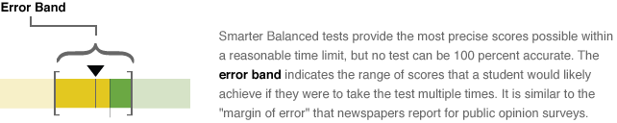

Figure - Error Band Illustration

* Error band meaning is explained in the Legend of each report that displays them:

Smarter Balanced tests provide the most precise scores possible within a reasonable time limit, but no test can be 100 percent accurate. The error band indicates the range of scores that a student would be very likely to achieve if they were to take the test multiple times. It is similar to the “margin of error” that newspapers report for public opinion surveys.

### Integration with Institutes of Higher Education (IHE)

* There is no separate user report for IHE, but there is specific IHE language to explain the 11th grade Individual STUDENT Report, which is configurable on a per-tenant basis:

Students in Grades 8 through 12 see Consortium-common higher education policy information, and a state-customizable link to state resources:

[http://stateresources.link](http://stateresources.link/)

* Eleventh grade Individual STUDENT Reports support IHE on a single student basis
* States can extract 11th grade assessment results via bulk assessment outcome extracts and provide it to IHE. There is no interface for IHE personnel to extract 11th grade assessment results on their own.

### Interim Assessment Blocks (IAB) Reporting

Reporting for Interim Assessment Blocks is currently in development. This document will be updated to include IAB content when development is complete.

### Interim Comprehensive Assessments (ICA) Reporting

ICAs are similarly designed to summative assessments, but are not equivalent.

From a Data Warehouse perspective, assessment outcomes and individual item responses appear identical between the two, except for the “assessment type” field. Assessment records also have a specific Academic Year (e.g., 2015 for the 2014-15 Academic Year) and Assessment Date (last date of the administration window). The Assessment Date is displayed on the assessment selector.

From a reporting perspective, ICA results are reported through the Individual STUDENT Reports (with overall and claim scale scores for each subject) and in aggregate form on the List of Students in a GRADE report.

From a policy perspective, an ICA is intended for use as a benchmarking tool, where administration requirements are less stringent than for the summative assessment. Consequently, summative results support higher-level aggregation (between grades, schools or districts) because the test conditions and administration requirements are comparable. ICAs, which may be administered with greater variations in test conditions, would introduce validity issues if aggregated and are therefore only reported on a per student basis.

The additional capability to aggregate ICA results—e.g. by way of assessment and/or date filtering—is documented as a future enhancement to the system.

#### Assumptions

1. On the List of Students in a GRADE report and Individual STUDENT Report, educators see a dropdown list of all assessments taken by that student or group of students.
2. Assessments are listed as “YYYY.MM.DD - Grade X - Type - Subject” (e.g., 2017.05.15 - Grade 4 - Summative - Mathematics).
3. Assessment retakes are sent in with the same name and date and replace the original assessment in reports; previous results are not deleted (available by extract), but they are not aggregated or reported on.
4. The list is not filtered and displays all assessments that have been loaded into the Data Warehouse. Restricting the list may be a future enhancement.
5. On the List of Students in a GRADE report, any assessment given to at least one of the students appears on the list. Students with no results for that assessment do not appear when that assessment is selected.
6. All reports for interim comprehensive assessments may be identical to the reports created for summative assessments as long as the appropriate qualifications are communicated. The following qualifications were endorsed by Consortium Leadership on 2014.07.16, and are accessed on the List of Students in a GRADE and Individual STUDENT Report by pausing on or clicking the blue information icon Macintosh HD:Users:jkenlon:Desktop:nav_icons.png:

Important Information About Interim Assessments

* Questions on interim tests that require human scoring may be scored locally by teachers. This local scoring is not subject to the rigorous controls used in summative assessments, and local results may show some variations.
* Interim assessment questions are not secure. Exposure to and familiarity with test questions may affect student performance and the accuracy of interim results.

1. There is no reporting for interim comprehensive assessments above the level of the List of Students in a GRADE for a grade in an individual school (no grade, school, or district comparison reports). (endorsed by Consortium Leadership on 2013.09.11)
2. All interim comprehensive assessment language/content for Qualifications or Descriptions have been provided by either the Test Design and Validation Work Group, Lead Psychometrician, or the 05-Interim Assessment Work Group, subject to any specifications from the Reporting vendor.

### Help

General help information and links to several sets of resources:

* Frequently asked questions (currently in development)
* Glossary (currently in development)
* Resources (links to keyword-driven search of the Digital Library)
* User Guide (created by Amplify with input from User Experience Study)

### HTTPS Pickup Zone

For download requests that are either 1) too large for direct download via the browser or 2) complex enough to require significant processing time, the download is made available via an HTTPS Pickup Zone.

Once the files have been generated and are available for pickup, the user can retrieve the file(s) from the URL provided to them. The download is only retrievable from the provided URL by the original requesting user.

The Pickup Zone relies on the authentication of the Smarter Balanced Single Sign-On component to validate that the appropriate user is accessing the file, and then securely delivers the file to the user via encrypted transmission using HTTPS.

There are no additional configurations or tools needed for a user to access the Pickup Zone other than the browser they are using to view reports and request downloads.

### Language Support

The textual content of the Reporting System is available for viewing and printing in English by default, but users can select alternative languages, including the Spanish and Vietnamese translations provided by Tri-Lin in their capacity as the vendor for Smarter Balanced translations.

### Legends

A Legend popup is available on each reporting page. It provides explanations for icons, color choices and other design elements of the reports.

### Logging

The Reporting System logs any access to confidential student data. Logs can be accessed by technical staff with appropriate permissions. Instructions are included in technical documentation (Runbooks).

All access to confidential data logs the user information and activities performed with the confidential data.

### Displaying hidden information

Information is sometimes hidden to provide additional detail or supporting information that would otherwise make the primary display confusing.

### Navigation

* Landing Page -Any user who is not logged in sees a landing page with a link to log in and a small number of links to public resources

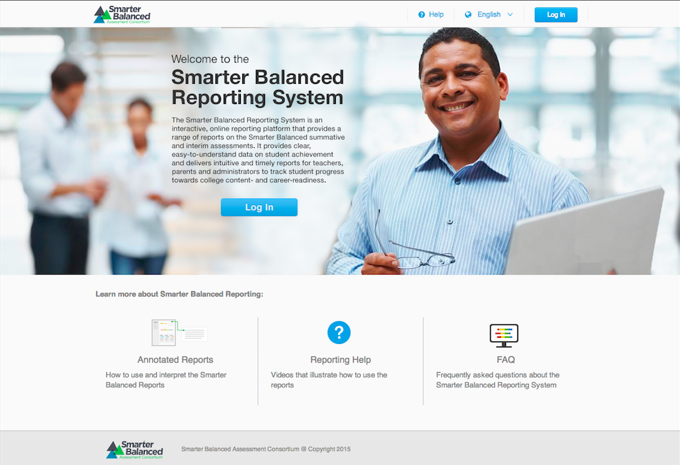

Figure - Reporting Landing Page (for logged out users)

* Breadcrumbs - All reports provide a breadcrumb trail to maintain user understanding of their current location, where each step in the trail is clickable to jump to that page to navigate through the report hierarchy.

****

Figure - Breadcrumb Navigation

* System provides links to public Digital Library Resources via the **Resources** button.
* Navigation is assessment-data driven, and the system cannot provide navigation to reports for any entities that do not have assessment data; e.g., if a school does not have assessment results in the Data Warehouse, it does not appear in the hierarchical list of aggregations. Conversely, any student record’s hierarchy generates the reporting hierarchy; i.e., if a single student’s assessment outcome exists, then that student’s grade, school, and district are navigable to enable access to that student’s Individual STUDENT Report (even if the aggregations are suppressed due to insufficient data).
* System has coherent navigation to and from reports and features, as well as a consistent user experience across stakeholders and reports.
* System does not provide jump-navigation to specific reports for any users based on account information or preferences.

### Optional Student Group

The intent of the student groupings is to provide a facility for states and districts to create optional subgroupings of students smaller than a grade. A possible use for these groupings would be to track teachers and instructors associated with students for filtering through the Reporting System or external systems.

The optional student group is exposed in reports to end users through the List of Students in a GRADE report, as an additional dropdown in the filter section:

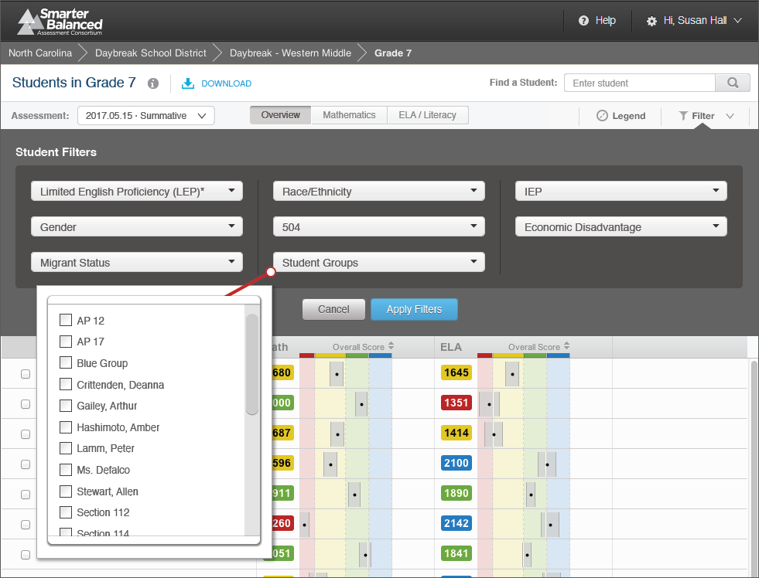

Figure - Optional Student Group Filter

The student group filter dropdown is dynamically generated from the students in the grade. All the unique values for any student group (up to 10 student groups may be created in the Test Registration system) are included in the dropdown. For example, for a given fourth grade, the Student Group dropdown contains a list of all unique Student Group values included in the assessment records for any of the students in that grade. Teachers who select their names from the list see only students associated to them in a Student Group.

Within the Student Group dropdown, a user may make multiple selections. If a user makes multiple selections within Student Groups, that filter includes the union-set of students matching the criteria. For example, selecting “Crittenden, Deanna” and “Stewart, Allen” would include all of the students who were in a Student Group for either Ms. Crittenden or Mr. Stewart.

If selections are made in more than one dropdown, then the system returns a set with the intersection of filters. For example, if a user selects “Crittenden, Deanna” as the value for Student Group, and “Yes” as the value for Migrant Status, then the resultant list of students includes only those students who have associations to Ms. Crittenden AND have been marked as “Yes” for Migrant Status.

### Permissions

Permissions are available for states, districts, and schools to manage access rights to features and information. Permissions are managed through the Smarter Balanced Permissions component.

For Reporting, the permissions available are feature-based, rather than role-based, and must be limited in scope to one or more schools, districts, or states. The features covered by permissions are:

* Assessment Completion Extract
* Audit XML Extract
* Individual Item Response Data Extract
* Student Assessment Results Extract
* Student personally identifiable information (also known as “PII Access”)
* Student Registration Statistics Extract

### Personally Identifiable Information (PII) Protection

There are two conditions that, when met, cause the system to suppress aggregated data for all users. Especially to protect the inherent PII in the latter case (when all students are below proficiency), the system displays “Data Suppressed to Preserve Anonymity” instead of an achievement level proportion bar.

* **Minimum Cell Size -** When any aggregation represents fewer than 10 students, the aggregation is not displayed, and the system displays the message “Data Suppressed to Preserve Anonymity”. If a user has authorization to view student PII for the students within that aggregation, clicking the aggregation name allows navigation to the next level down in the reporting hierarchy.
* **All below proficiency -** When educators view aggregate views of student data, if 100% of the students in a given aggregated subpopulation scored in Level 1 and Level 2 (below proficiency), and the educator does not have rights to view the PII of those students, then the application does not display any information about those students. The system displays the message “Data Suppressed to Preserve Anonymity”.
  + This rule only applies if 100 percent of students in a grouping are level 1 or 2.
  + Conversely, if 100 percent of students are level 3 or 4, the information is displayed.

### Printing, Individual and Batch

#### Individual Printing

The Individual STUDENT Report has a special printer-friendly output in PDF format to ensure all report and supporting information is included in the printout, and should be suitable for distribution to students, parents, and teachers.

All other reports print directly from the browser using the standard Ctrl+P print command.

#### Batch Printing

Batch printing is available through the Reporting System to help distribute printed versions of the Individual STUDENT Report.

*List of Students in a GRADE*

The authorized user can request a batch print of the Individual STUDENT Report for all of the students included in the current view. If a user has filtered or selected some subset of students, then the batch print includes only those visible.

*Results by Grade for a SCHOOL*

The authorized user can request a batch print of the Individual STUDENT Report for all of the students in the school or a subset of the school (e.g., certain grades, filtered list). If a user has filtered to a specific subset of students, then the batch print includes only those students who meet the limiting criteria.

To make it easier for users to download and print the Individual STUDENT Reports, the download is split automatically by grade. So a user who requests a download of all the students from a middle school receives three PDF files, one for each grade.

*Comparing Schools in a DISTRICT*

To ensure that reporting system performance is not negatively affected, batch printing is not available at the district level.

*Comparing Districts in a STATE*

To ensure that reporting system performance is not negatively affected, batch printing is not available at the state level.

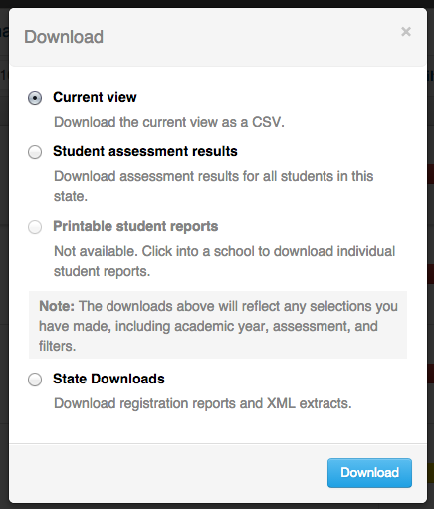

Figure - Download Popup Window

*Download popup window*

When a user clicks the **Download** button on the List of Students in a GRADE or Results by Grade for a SCHOOLreports, the Download window displays (see above).

From that popup window, users can:

1. Download the current view as a CSV file - this downloads a CSV version of the current version of the report (including any filters or sorting) into the browser. This allows users to read the data in tabular form.
2. Download the student assessment results - this downloads the raw assessment result data (as a CSV file) captured for the summative assessment for all the students whose scores are represented in the current report. This choice is only available to users who have PII access to the underlying students.
3. Download printable Individual STUDENT Reports - this downloads the Individual STUDENT Reports for all underlying students in one combined PDF. Clicking this option opens a second popup window (see below).

*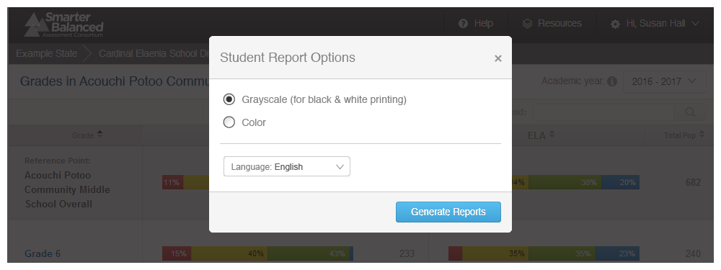*

Figure - Printable Student Report options

*Report options popup window*

When a user downloads the printable student reports from the Download popup window, a second popup window appears. This window allows the user to customize their batch print job as follows:

* Grayscale (for black and white printing) or color. Grayscale is default.
* Language Support - to print the reports in either Spanish or Vietnamese

Once the options are selected and the **Download** button is clicked, the Report URL window (see below) opens.

*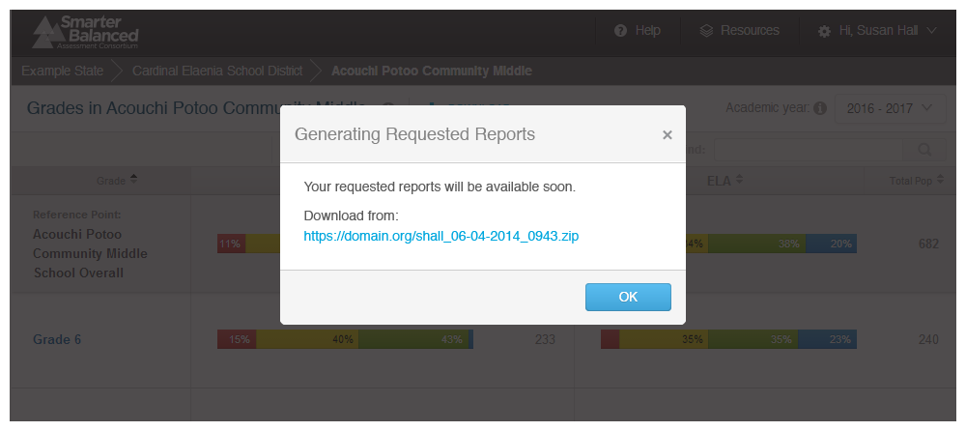*

Figure - Download Confirmation Window

*Report URL popup window*

When the user clicks the **Download** button on the Report Options popup window,the above popup window appears. It notifies the user of the URL or URLs (for multiple files) where their file will appear. The user is then able to click the URL to receive their requested file.

Once a user initiates a batch-print request, the job is scheduled in a queue, and it may take some time to complete depending on the size of the queue and other demands on the system. The job includes steps to generate the pages for the selected reports, integrate the individual student reports into one or more large PDF files, and deposit the PDF files to the HTTPS Pickup Zone.

For a batch-print request made from a List of Students in a GRADE report, all selected students are included, and their reports are arranged alphabetically by last name in the large PDF files. At this level, most batch-print requests are less than 1,000 students in a single grade, and therefore likely contained in a single large PDF file. If there are more than 1,000 students, the batch-print is split into multiple PDF files.

For a batch-print request made from the Results by Grade in a SCHOOL report, PDFs is generated separately for each grade, which results in at least one large PDF per grade. If a given grade has more than 1,000 students, then that grade is split into multiple PDF files.

The PII Access permission extends to the Batch Printing feature. If a user does not have PII Access permissions, they do not have the batch print option available.

If users are authorized to see the List of Students in a GRADE report, they have PII Access. However, a user without PII access rights may have access to the Results by Grade for a SCHOOL report; in that case, the user does not see the batch-print download option.

### Reporting API

The Reporting System supports API calls, leveraging the Single Sign-On shared service for authentication. This provides member states the ability to create additional software to integrate with the system. Specific examples of integration include automating extract triggers between systems or serving an Individual STUDENT Report to an authorized user through a state system.

### Security

The Reporting System automatically logs users out after a configurable specified number of minutes with no activity. The period is set by the SSO component and is currently assumed to be 30 minutes.

### Scale Score

All reporting is based on scale scores produced by the Scoring component of the Platform. Each subject (mathematics and ELA/literacy) has an overall Composite score and a small number of Claim scores calculated in the Scoring component and integrated by Test Integration into the test XML. Overall scale scores are exposed on the Individual STUDENT Report and the List of Students in a GRADE Report, while Claim scale scores are only exposed through data extract. The scoring integrator component also calculates any Achievement Levels, Categories, Claim levels and Error Bands.

### Section 508 Compliance

The Reporting System is in compliance with accessibility requirements specified in Section 508 Amendment to the Rehabilitation Act of 1973, specifically the following subsections:

* 1194.21 - [Software Applications and Operating Systems](http://www.section508.va.gov/docs/checklist_1194_21.pdf)
* 1194.22 - [Web-based Intranet and Internet Information and Applications](http://www.section508.va.gov/docs/checklist_1194_22.pdf)
* 1194.31 - [Performance Criteria](http://www.section508.va.gov/docs/checklist_1194_31.pdf)
* 1194.41 - [Information, Documentation, and Support](http://www.section508.va.gov/docs/checklist_1194_41.pdf)

Amplify has reviewed the system to ensure that information is equitably accessible.

#### Individual STUDENT Report

The Individual STUDENT Report has a special PDF print capability, but does not provide a non-visual/tabular download. The report can be navigated using the keyboard and accessed in screen readers. The visual design elements are rendered in sufficient color contrast

#### List of Students in a GRADE

For a List of Students in a GRADE, the user must have access to PII to view the report; therefore anyone who can see this report can download either or both of the following extracts:

1. **Download Current View as CSV** - This provides the user with a full extract of the assessment outcomes only for the students that are visible at the time, as it takes into account the state of all sort, filter, and selection options.
   1. For Mathematics and ELA/literacy view, this CSV file provides the Overall scale score, Overall error-band, and Overall achievement-level data for both subjects for each student.
   2. For Subject-Detail view, this CSV file provides the Overall scale score, Overall error band, Overall achievement level, and the Level (1, 2, 3) and Label (Below, At/Near, Above Standard) for each Claim in the selected subject.

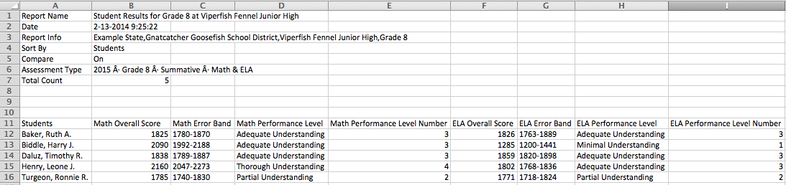

Figure - List of Students in a GRADE, Download Current View as CSV example

1. **Download Student Assessment Results** - This provides the user with a full extract of the assessment outcomes for all the students in the GRADE (see also Section 1.2.1 - Student Assessment Results).

#### Results by Grade for a SCHOOL

All users can download the current view.

Only users with PII access for the SCHOOL can download the raw data for the SCHOOL.

1. **Download Current View as CSV** - This provides the user with a full extract of the assessment outcomes only for the aggregations visible at the time, as it takes into account the state of all sort, filter, and selection options.
   1. This CSV file provides the counts and percentages for every achievement-level proportion bar on the screen.
   2. If there is “Data Suppressed to Preserve Anonymity”, the CSV file is suppressed in the same way as the report display; i.e., the rows are represented but there are no counts or percentages wherever “Data Suppressed to Preserve Anonymity” is displayed.

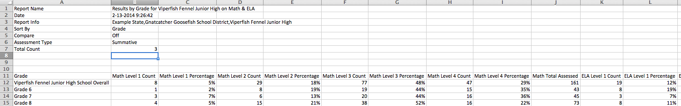

Figure - Download Current View as CSV - Suppressed Data

Again, only users with PII access for the SCHOOL can download student assessment results:

1. **Download Student Assessment Results** - This provides the user with a full extract of the assessment outcomes for all the students in the SCHOOL (see also Section 1.2.1 - Student Assessment Results).

#### Comparing Schools in a DISTRICT Report

All users can download the current view.

1. **Download Current View as CSV** - This provides the user with a full extract of the assessment outcomes only for the aggregations visible at the time, as it takes into account the state of all sort, filter, and selection options.
   1. This CSV file provides the counts and percentages for every achievement-level proportion bar on the screen.
   2. If there is “Data Suppressed to Preserve Anonymity,” the CSV file is suppressed in the same way as the report display; i.e. the rows are represented but there are no counts or percentages wherever “Data Suppressed to Preserve Anonymity” is displayed.

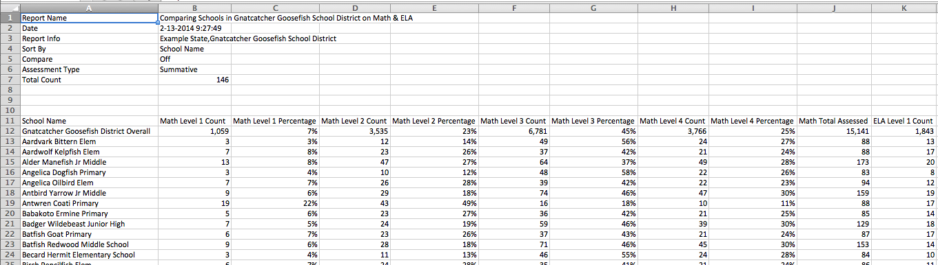

Figure - Download Current View as CSV aggregate report

Again, only users with PII access for the DISTRICT can download Student Assessment Results:

1. **Download Student Assessment Results** - this provides the user with a full extract of the assessment outcomes for all the students in the DISTRICT (see also Section 1.2.1 - Student Assessment Results).

#### Comparing Districts in a STATE Report

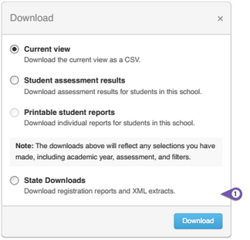

Figure - Comparing Districts in a STATE: Download options

All users can download the current view.

1. **Current View -** This provides the user with a full extract of the assessment outcomes only for the aggregations visible at the time, as it takes into account the state of all sort, filter, and selection options.
   1. This CSV file provides the counts and percentages for every achievement level proportion bar on the screen.
   2. If there is “Data Suppressed to Preserve Anonymity”, the CSV file is suppressed in the same way as the report display; i.e. the rows are represented but there are no counts or percentages wherever “Data Suppressed to Preserve Anonymity” is displayed.

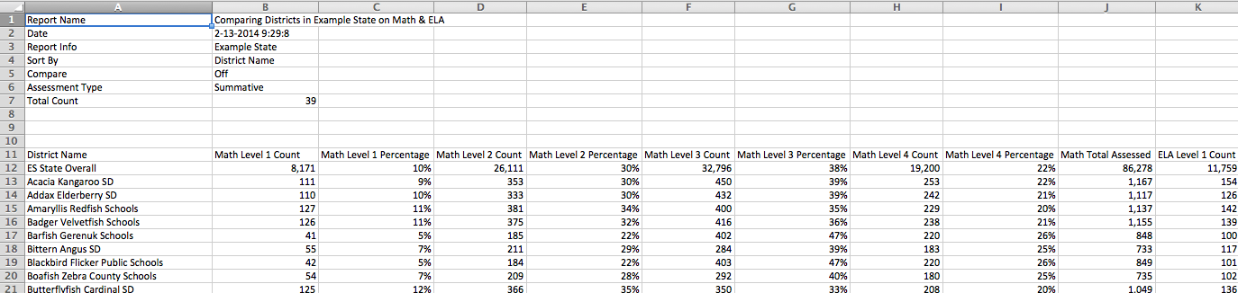

Figure - Download Current View as CSV aggregate report

Any users with state extract access can request state data as bulk extract.

1. **Student Assessment Results** - Selecting this option opens an additional dialog, allowing for the selection of state-extract-type, assessment type(s), subject(s). The download contains all Student Assessment Results for the state that meet the specified criteria and is provided via the HTTPS Pickup Zone to the requesting user.

### Summative Assessments

Reports of summative assessment results are end-of-year status reports, and are primarily used for student-parent-teacher level-setting and administrative review. Because of the well-defined administration parameters and process in place, the Consortium has approved reporting of summative assessment outcomes from individual students to the grade, school, district, and state levels. Reports provide aggregations of summative assessment outcomes for districts, schools, and grades. These aggregations are presented as Achievement Level proportion bars, and provide summary information about student performance in terms of grade-specific standards.

### Tenancy

* All user accounts (except Consortium administrators) provide access to one state only.
* Registered users within one state do not have access to another state’s data.
* Each state registers its users independently.
* A user who maintains roles in two states (e.g., administrator in one, teacher in another) has two user logins, one for each state’s data tenant.
  + Parents and students do not have logins or user accounts in the Smarter Balanced SSO.

#### Tenancy Personae:

For the use cases listed below, it was helpful to provide specific, named examples of user situations:

* Marty has a system role of Consortium administrator
* John is a district administrator in Oregon
* James is a district administrator in Oregon and a teacher in a separate Oregon district
* Linda is a district administrator in Oregon and a teacher in Washington
* Henrik is an unregistered education consultant in Norway

#### Tenancy Use Case 1

Registered users can only see data in their states.

* John from Oregon logs in and can only see data for Oregon.
  + John cannot see any reports for any other state while logged in as John from Oregon.
* James can freely explore all Oregon reports that he has access to in his various roles
  + James cannot see any reports for any other state while logged in as James from Oregon.

#### Tenancy Use Case 2

All registered user accounts belong to one state unless they have the Consortium Administrator role, in which case they can access all states.

* If users maintain roles in multiple states, they have separate logins for each state
  + Linda must log in with her Oregon credentials to explore Oregon’s reports, and cannot see Washington’s reports.
  + Linda must log out from her Oregon account and log in with her Washington account to see Washington reports (and then cannot see Oregon reports).
  + Marty logs in and can select from among all states to explore reports (including any to which she has PII access) and initiate extracts.

#### Tenancy Use Case 3

There isno support for anonymous public users(i.e., unregistered, logged out, or not logged in).

* If Henrik somehow gets a URL to the Reporting System, he cannot see anything except the logged out landing page with publicly available support materials.

## Technical Requirements

### Viewing reports

Reports are designed to be viewed using standard up-to-date browsers running on most available hardware:

* Chrome version 31 or higher (Windows and Mac)
* Firefox version 26 or higher (Windows and Mac)
* Internet Explorer 9 or higher (Windows only)
* Safari 7 or higher (Mac only)

Otherwise for Reporting System users, the technical requirements for viewing reports do not exceed or extend the technology readiness requirements established by Smarter Balanced.

### Data Sources

AIR (as vendor for RFP-11 Test Delivery System, including Test Score Integrator) has committed to implementing, in the operational system, all calculations required to support the data requirements specified by the Consortium through the course of work completed with vendors.

### Reporting Technology Stack

The reports are built on top of the Data Warehouse using the following technologies:

#### Client Side Technologies

CoffeeScript, RequireJS, jQuery, Mustache, Bootstrap, qUnit

#### Server Side Technologies

Python 3.x, Pyramid, SqlAlchemy, Zope Components

#### Database/Middleware

Postgresql 9.x, pgbouncer, pgpool-II, repmgr, memcached

#### Testing Tools

pyUnit, nose, selenium/webdriver, sqlite

#### Other Software

[apache tomcat](http://tomcat.apache.org/) - open source Java Servlet / JavaServer Pages technologies

[nutcracker](http://nutcracker.sourceforge.net/) - open source tool to support animations

[wkhtmltopdf](https://code.google.com/p/wkhtmltopdf/) - open source html-to-pdf generator using webkit

[Celery](http://www.celeryproject.org/) - open source asynchronous task queueing

[GlusterFS](http://www.gluster.org/about/) - open source distributed file system

[RabbitMQ](http://www.rabbitmq.com/) - open source intra-component messaging

## Member-State Configuration and Extension of the Reporting System

The Smarter Balanced Reporting System provides member states the ability to configure:

1. The graphic logo and title area that applies to all online reports
2. Direction to state resources for college content and career readiness

More extensive customization and extension of the Smarter Balanced Reporting System and Data Warehouse components are made possible through member state access to content and source code. Member states that choose to implement their own instance of the reporting system can modify descriptive text to align with their particular needs; all content structures/constraints/etc. are included in the technical documentation.

1. State Logo and Title

The Reporting System currently includes the Smarter Balanced logo in the upper-left corner of the navigation area. States may update their instances to display a state logo. Transparent/color background logo choice is left up to the state designer, but the process is a simple image swap:

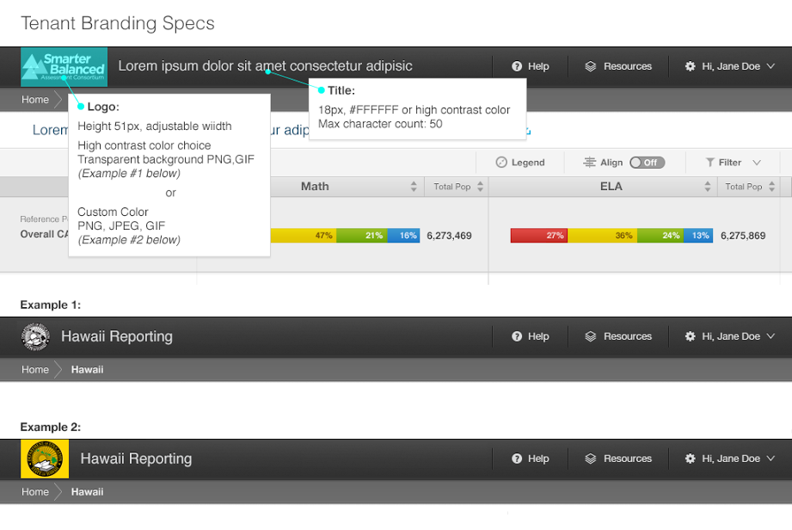

Figure - Member State Customizable Logo and Title

1. College Content-Readiness Resources

Smarter Balanced has determined that each state may customize the content of one area for their eighth and 11th grade student reports to include a link, pointer, or other direction to state-maintained college content and career readiness materials.

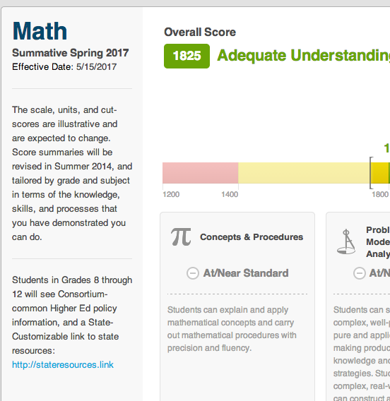

Figure - Member State Configurable Resources

Applying the state-provided content is a system configuration.

## Documented Assumptions and Clarifications

### Truth at Test Time

The Reporting System provides snapshots of student performance at a moment in time. Reports are organized by the information available provided by the Test Delivery System at the time of assessment, including student information and attribution information. Testing hypothetical situations or extrapolations are not supported.

### Data-Driven Hierarchy

Individual student records drive all the reports, and the reporting hierarchy is derived from those records. Any attribution or grouping information is provided at test time by the Test Delivery System, and is not managed or maintained in the Data Warehouse or via the Reporting System.

### Enrollment

The Data Warehouse and Reporting System solution is an assessment reporting system and does not have an operational or transactional data store to support reporting on enrollment. It may be used in conjunction with a system that does.

### Instructional Use

The Digital Library is a good source for additional tools and modules that help address instructional questions that may be raised by inferences supported by assessment results.

### Statistical Analysis

The Data Warehouse contains sufficient information to support statistical analysis, and the download/extract capabilities provide the ability to export data to more fully-featured statistical solutions such as SPSS, Minitab, R or Microsoft Excel. The Data Warehouse’s star schema structure supports integration with OLAP tools.

### Longitudinal Data and Student IDs

All data in the Data Warehouse is implicitly longitudinal, in that all results for a given student are connected by that student’s ID.

* Version 1 of the system provides reporting designed for one year of data due to additional requirements gathering needed for appropriate display of data over time.
* Amplify provides visual design services to document direction for future reporting capabilities, including the following year-over-year reports:
  + Reporting on multiple years of summative data for Comparing Districts in a STATE, Comparing Schools in a DISTRICT, and Results by Grade for a SCHOOL reports
  + Reporting on multiple years of summative and interim comprehensive assessment data for the List of Students in a GRADE report
  + Reporting on multiple years of summative and interim comprehensive assessment data for the Individual STUDENT Report
* The identity management systems of each state are responsible for reconciling multiple student IDs generated for a single student into a single student ID.
* The Reporting System are dependent on the state identity management systems to provide student IDs.

### Comparing Aggregates

* The Reporting System compares aggregates to each other via the following reports:
  + Comparing Districts in a STATE
  + Comparing Schools in a DISTRICT
  + Results by Grade for a SCHOOL
* The Reporting System provides the ability to filter to subpopulations of interest across aggregates, including by grade(s), demographics, and school programs.
* The Reporting System does not provide a way to directly create a gap analysis. Sophisticated cross-tabs and conditional analyses are supported only by external tools populated through data extracts.
  + For example, the Reporting System does not provide a way to analyze fifth grade summative mathematics assessment and compare Hispanic LEP males to non-Hispanic, non-LEP males.
  + The Reporting System does not provide multi-year aggregate reporting or comparison between assessment administrations. The Data Warehouse provides data extracts to support offline calculation of trend or growth data.
* As requested by the Consortium, the Reporting System does not support comparisons between different states.

### Group and Permission Definitions

* Configuration of user groups and permissions are maintained through the SSO shared service. Users are associated with school(s)/district(s)/and state(s) by their state.
* All user associations are passed to the Data Warehouse by the state identification management system.

### System Functionality Restrictions

* System functionality in the Data Warehouse and Reporting System is granted or restricted to user groups or entities, including Smarter Balanced, state, district, and school building levels by system administrators.
* Permissions are feature-based.

### Statistical Support

* The Data Warehouse and Reporting System contain and make available data to allow for:
  + Conditional Analyses - Basic conditional analyses are achievable through filtering of reports. More advanced analyses require external tools applied to data extracted from the Data Warehouse.
  + Basic Inferential Tests - Offline regressions (e.g., psychometric calibration, state/district custom metrics) require the use of external tools applied to data extracted or downloaded from the Data Warehouse.
  + Frequencies - They are available in both the comparing populations and Results by Grade for a School reports.
  + Crosstabs - They require the use of external tools applied to data extracted from the Data Warehouse.
* The Data Warehouse and Reporting System do not support:
  + Descriptive Statistics - As per direction of Psychometric validation partner ETS, Amplify recommends against publishing mean or quartile scores for a given aggregation.

### Availability of Data

* Reports and data are made available as soon as incoming assessment results are completely processed.
* Assessment results are provided to the Reporting System by a Test Score Integrator which integrates all the scoring information into a final set of scale scores, error bands, cut-scores, and achievement levels and provides a bulk upload of assessment results for a given administration (e.g., DE 2017 Grade 6 Summative ELA). Reporting latency is primarily driven by Scoring latency.
* The service level agreement for reporting is:
  + Upon receipt of data from Test Integration, data will be visible in the Reporting System within 24-96 hours.
  + This agreement is subject to change as specifications and hardware characterizations are finalized.
* The service level agreement for data extracts may be longer than 96 hours but is dependent on system activity and available resources.
* Data and reports are released to all users with the appropriate level of access as and when the data are processed, which depends on the aggregation rules in effect in the source system. There is no timed, staged, or staggered release of reports, and data are not embargoed for any period of time, i.e. as soon as an assessment result is live in the Data Warehouse, the assessment result is reportable and reported on.